B.H. College, Howly UBA
B. H. College, Howly was established in 1966. This institution of higher learning serves the socially and economically backward people of a vast area. The college is affiliated to Gauhati University and it is the oldest higher educational institution and also offers M.Com, M.A in Education and Assamese regular course under Gauhati University.
The college which is affiliated to the Gauhati University has also been included under section 2 (f) of UGC act 1956. The college is imparting quality education to the students and at the same time installing in them the moral and ethical values necessary for leaving in harmony with others. The college is a medley of students belonging to different ethnic group with perfect harmony. The college has been accredited by NAAC in 2016 accredited with “A” Grade. Thus, B. H. College, Howly is imparting higher education to the students as well as contributing a lot to the society in different aspects. Under the Unnat Bharat Abhiyan scheme also the college has adopted five (05) villages in Barpeta District namely Moutupuri, Madulijhar, Barbari Jhar, Shimlajhar and Raypur.
Sl. No | Villages | Block | District
1. | Moutupuri | Gobardhana | Barpeta
2. | Madulijhar | Gobardhana | Barpeta
3. | Barbari Jhar | Gobardhana | Barpeta
4. | Shimlajhar | Gobardhana | Barpeta
5. | Raypur | Gobardhana | Barpeta

VILLAGE HOUSEHOLD SURVEY
Under the UBA scheme of B. H. College, Howly, the college has adopted five (05) villages in Barpeta District namely Moutupuri, Madulijhar, Barbari Jhar, Shimlajhar and Raypur. In these villages different teams are assigned responsibility to make survey and to collect different statistical data in connection with socio economic condition of the villages. The household survey was started from the month of April 2020.
Name of the Village : Moutupuri
Block : Gobordhana
District : Barpeta
State : Assam
Pin Code 781316
Post Office : Moutupuri Branch Post Office
Assembly Constituency : Barnagar LAC
Lok Sabha Constituency : Barpeta
Area of Village : 173.65 Hectares
Agriculture Area : 129.62 Hectres
Forest Area : Nil
Water Table : 40 feet
Common Lands : Nil
Area under water bodies : Nil
Communication Language : Assamese & Bengali
District Head Quarters : Barpeta (18 K.M)
State Head Quarters : Dispur (Guwahati) (113 K.M)

Nearest Cities | : Barpeta
Literacy Rate | : 86.49%
Total No. of Houses | : 261
Total Population | : 1184
Male Population | : 603
Female Population | : 581

MAJOR FINDINGS OF THE SURVEY IN THE VILLAGE

Drinking water :
During the survey it is found that 82 % of the total population used water of open well and hand tube well. Only 18% of the total population used the running water supplied by the Government.

Transport facility :
Transport facility is found to be satisfactory to some extent. 65% of the length of total road is found to be pitch and graveled, roughly constructed. Of course, some roads of the village are yet to be made pitch. It is near about 10 K.M. to the railway station and 3 km from bus station from the village.

Employment :
During the survey it has been found that 89% of the total population are farmers and labours (daily wage earners). Only 11% are Government service holder.

Health Care :
For Medical emergencies, 1 primary health care is available at a distance of 2.5 km, at 15 K.M. distance the nearest Govt. Hospital is situated at Barpeta Road. 1 medical shop is available in the village.

Toilet Facility :
99% toilet facility is available in the village of which 73% is Swatch Bharat toilet.
75% are private pucca toilet and other 3% are katcha toilet made of wood and bambo.

Electricity :
Electricity is available in every household of which 53% household have availed under BPL (Government Supply).

Literacy :
During the survey it is found that only 11.10% of the total population is found to be class 5 passed, 10.09% are class 8 passed, 16.3% are class 10 passed, 15.90% are class 12 passed, 41.40% are graduate, 3.70% are post graduate.
- Housing :
Most of the houses of the village are katcha i.e. 55% where as 28% are semi pucca and 17 % are pucca.

MAJOR PROBLEMS
Following are the major problems in the village :-
  - Lack of Govt. transport facility
  - Lack of hospital facilities
  - Problem of sanitation
  - Lack of irrigation facility
  - Lack of cottage industry
  - Problem of unemployment

SUGGESTIONS FOR DEVELOPMENT
- Proper steps should be taken to increase the literacy rate of the people in the village.
- Cottage and small industry may be established for the purpose of eradication of educated unemployed youth.
- Irrigation facility should be provided for the farmers.
- Awareness camp should be organised to reduce the drop out students in the village.

VILLAGE SURVEY PHOTOGRAPH OF MOUTUPURI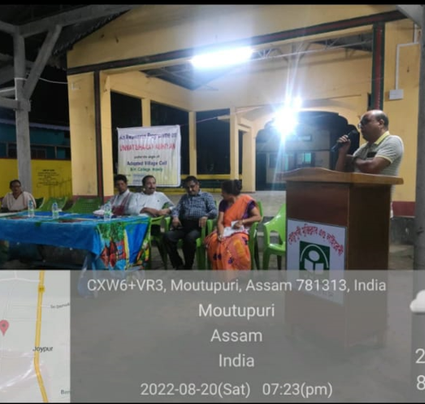

MADULIJHAR VILLAGE DETAILS
Name of the Village : Madulijhar
Block : Gobardhana
District : Barpeta
State : Assam
Pin Code 781317
Post Office : C bazar Branch Post Office
Assembly Constituency : Barnagar LAC
Lok Sabha Constituency : Barpeta
Area of Village : 252.44 Hectres
Agricultural Area : 179.42 Hectres
Forest Area : Nil
Water Table : 30 feet
Common Lands : Nil
Area under water bodies : Nil
Communication Language : Assamese & Bengali
District Head Quarters : Barpeta (21 K.M)
State Head Quarters : Dispur (Guwahati) (115 K.M)
Nearest Cities | Barpeta
Literacy Rate | 75.23%
Total No. of Houses | 669
Total Population | 2774
Male Population | 1390
Female Population | 1384

MAJOR FINDINGS OF THE SURVEY IN THE VILLAGE

Drinking water :
It has been found during the survey that 98% of the total population use hand pump for drinking water. There is six community water tape in the village.

Transport facility :
In the village bike, cycle, e-rickshaw and private vehicle are used as the main mode of transportation. The nearest highway is five (05) K.M away from the village and the village by a semi-pucca, gravel road. The internal road inside the village is found to be kachha.

Employment :
53% of the total population is employed in farming on their own land and 14% farmers is engaged in sharecropping and leased land. Skilled wage earners are found to be 31%. Only 2% of the total population are Govt. employees and 18% are engaged in trade and business.

Health Care :
There is 1 primary health centre in the village. The nearest health centre is 1.5 K.M away from the village. At 15 K.M. distance the nearest Govt. Hospital is situated at Barpeta Road.

Toilet Facility :
Most of the people of the village use private toilet. 78%. Most of them have got the benefit of Swachh Bharat Mission toilet.

Electricity :
97% households are connected with electricity. 45% also get the facility of electricity concession under BPL category. Electricity used to remain for an average 12 hours.

Literacy :
The literacy rate in the village is found to be 75.33%%.

Housing :
All the households have their own house of which 65% are pucca house, 15% is semi pucca and 20% is found to be kuchha.

MAJOR PROBLEMS
Following are the major problems in the village :-
- Problem of unemployment
- Flood
- Problem of sanitation
- Lack of Govt. transport facility
- Lack of irrigation facility
- Lack of hospital facilities
- Lack of small scale industry
- No proper drainage system
- Non-recipient of the facilities of various government schemes

SUGGESTIONS FOR DEVELOPMENT
- Awareness programme should be organised by the Govt. as well as NGOs on health and hygiene in the village.
- Proper steps should be taken to increase the literacy rate of the people in the village.
- Cottage and small scale industry should be established in the village to increase the self-employability of the local educated youth.
- Proper drainage system should be initiated.

VILLAGE SURVEY PHOTOGRAPH OF MADULIJHAR

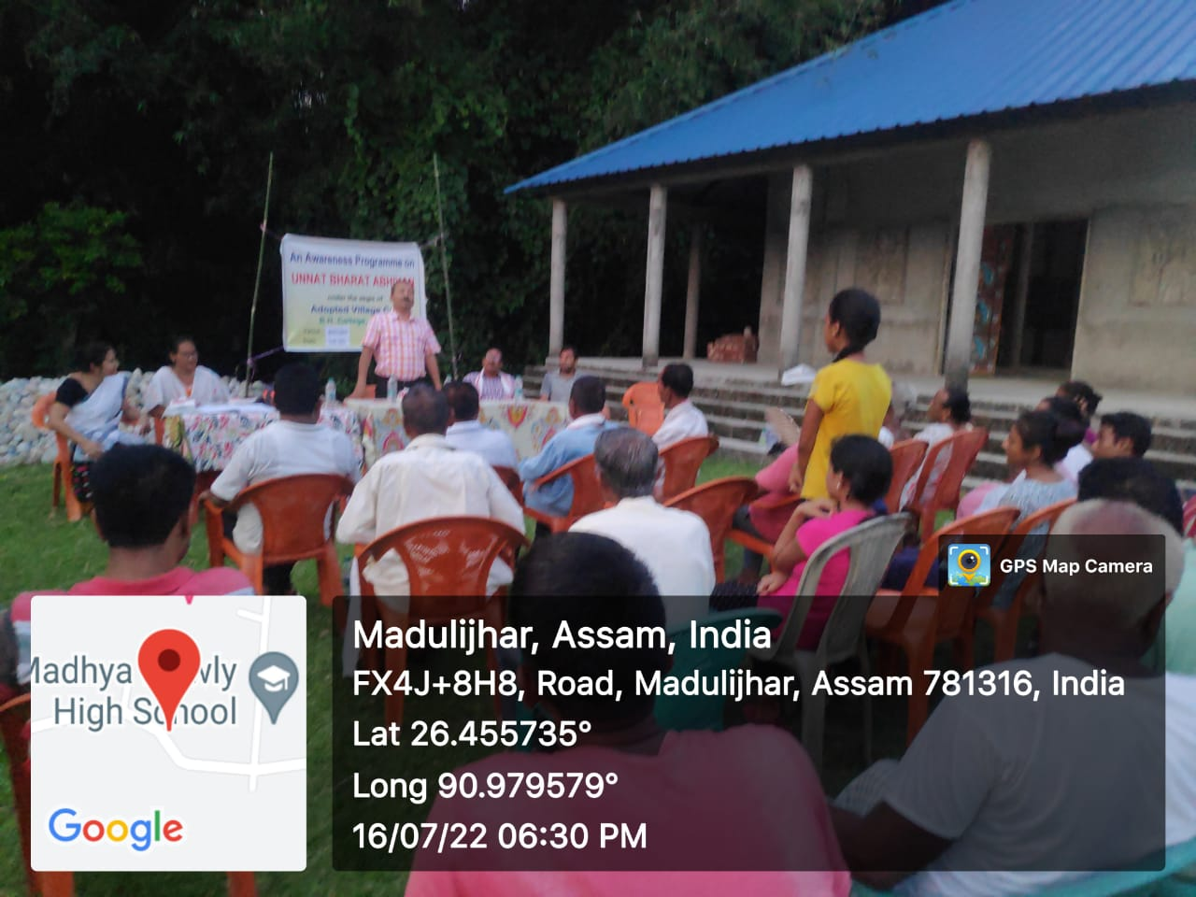

BARBARI JHAR VILLAGE DETAILS
Name of the Village : Barbarihjhar
Block : Gobardhana
District : Barpeta
State : Assam
Pin Code 781313
Post Office : Balabhita Branch Post Office
Assembly Constituency : Barnagar
Lok Sabha Constituency : Barpeta
Area of Village : 168.98 Hectres
Agricultural Area : 81.84 Hectres
Forest Area : Nil
Water Table : 45 feet
Common Lands : Nil
Area under water bodies : Nil
Communication Language : Assamese & Bengali
District Head Quarters : Barpeta (18 K.M)
State Head Quarters : Dispur (Guwahati) (120 K.M)
Nearest Cities | Barpeta
Literacy Rate | 62.60%
Total No. of Houses | 322
Total Population | 1654
Male Population | 873
Female Population | 781

MAJOR FINDINGS OF THE SURVEY IN THE VILLAGE

Drinking water :
Majority of the people of the village are getting clean and safe drinking water but some are yet to get the same. They all have private hand pump and 11 % of them have tap water facility also.

Transport facility :
In the village bike, cycle, e-rickshaw and private vehicle are used as the main mode of transportation. The nearest highway is ten (5) K.M away from the village and the village by a semi-pucca and gravel road. The internal road inside the village is found to be kachha and gravel.

Employment :
Near about 83% people of the village are engaged in agricultural activates. The service holders in the village is only 11% of which majority are employed in defence service. 6% are having their small business and livestock farming.

Health Care :
There is no primary health center in the village. The nearest health centre is 5 K.M in the nearby village. The village is 13 km away from Barpeta Road Govt. Hospital.

Toilet Facility :
All the people in the village have their own toilet facility either of pucca or kuchha. 76% have also avail the facility of Swachh Bharat Mission toilet facility.

Electricity :
All the households in the village are connected with electricity of which 38% have avail the BPL electricity connectivity. The electricity remains for 15 hours at an average per day.

Literacy :
The literacy rate in the village is found to be 62.60%.

Housing :
All the households have their own house of which 56% are pucca house, 21% is semi pucca and 33% is found to be kuchha.

MAJOR PROBLEMS
Following are the major problems in the village :-
- Problem of unemployment
- Flood
- Lack of Govt. transport facility
- Lack of irrigation facility
- Lack of small scale industry
- Lack of hospital facilities
- No proper drainage system
- Problem of sanitation
- Non- recipient of the facilities provided by various government schemes.

SUGGESTIONS FOR DEVELOPMENT
- A primary health care centre should be established.
- Irrigation facility should be provided for the farmers.
- Cottage and small industry may be established for the purpose of eradication of educated unemployed youth.
- Proper steps should be taken to increase the literacy rate of the people in the village.
- Proper drainage system should be initiated.

VILLAGE SURVEY PHOTOGRAPH OF BARBARI JHAR
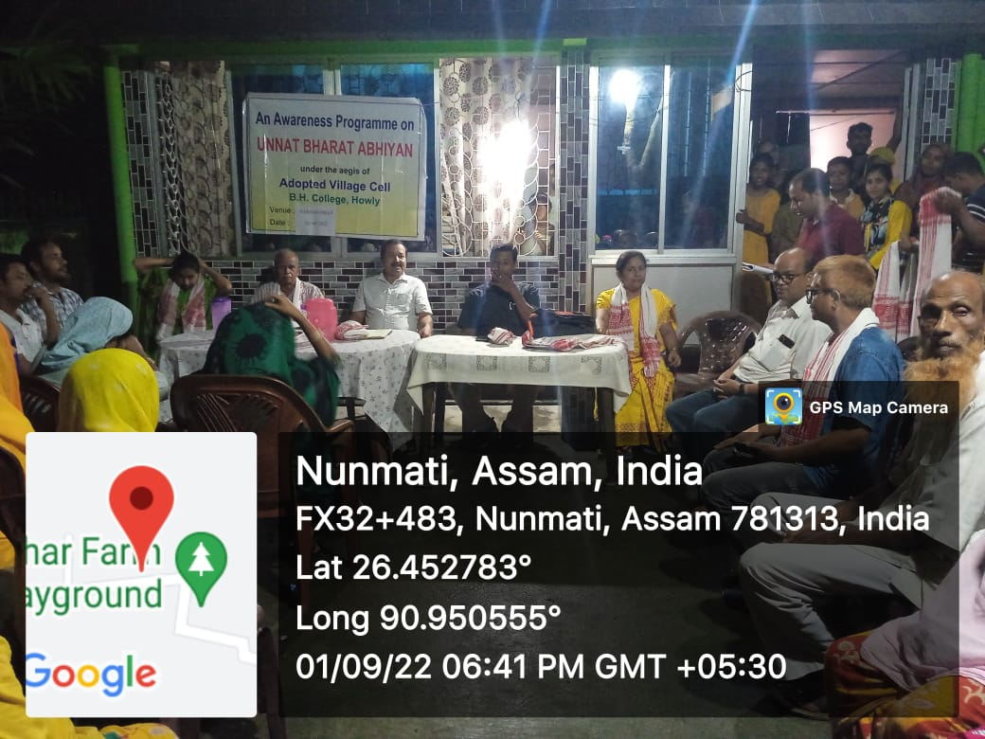

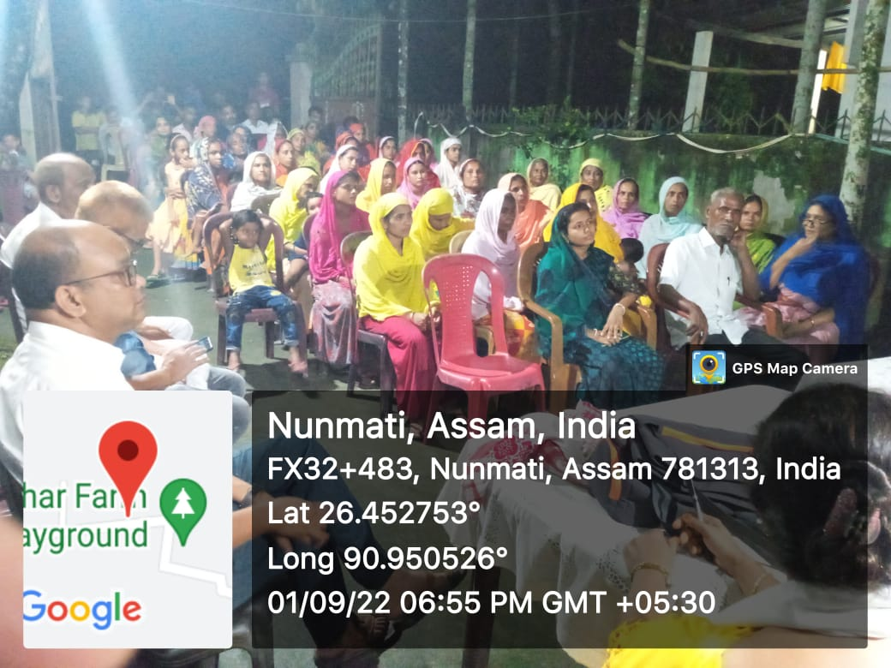

SIMLAJHAR VILLAGE DETAILS
Name of the Village : Simlajhar
Block : Gobardhana
District : Barpeta
State : Assam
Pin Code 781318
Post Office : Sarupeta
Assembly Constituency : Barnagar
Lok Sabha Constituency : Barpeta
Area of Village : 613.84 Acres
Agricultural Area : 529.99 Acres
Forest Area : Nil
Water Table : 42 feet
Common Lands : Nil
Area under water bodies : 5.65 Acres Communication Language : Assamese,Bengali
District Head Quarters : Barpeta (18 K.M)
State Head Quarters : Dispur (Guwahati) (120 K.M)
Nearest Cities : Barpeta
Nearest Cities | Barpeta
Literacy Rate | 50.03%
Total No. of Houses | 352
Total Population | 1723
Male Population | 884
Female Population | 839

MAJOR FINDINGS OF THE SURVEY IN THE VILLAGE

Drinking water :
The villagers mostly use the tube well and open well for drinking water. All families have private water facility. 3 community piped water facility is also available in the village.

Transport facility :
The transport facility in the village is very poor. Mostly private vehicle, e-rikshaw are used as means of transport. The roads inside the village are found to be kuchha. It is near about 13 K.M. to Barpeta Railway station and 5 km from public bus stand from the village.

Employment :
Near about 82% people of the village are engaged in agricultural activates. The service holder in the village is only 1%. 17% are engaged in small business.

Health Care :
There is no primary health centre in the village. The nearest health centre is 15 K.M away from the village i.e., Barpeta Road Civil Hospital.

Toilet Facility :
All the families have private toilet facilities of which some are pucaa and some are kuchha. A good numbers of families have been able to have the toilet facilities under Swachch Bharat.

Electricity :
All the households in the village are connected with electricity of which 25% have avail the BPL electricity connectivity. The electricity remain for 14 hours per day.

Literacy :
The literacy rate in the village is found to be 50.03%.

Housing :
All the households have their own house of which 51% are pucca house, 31% is semi pucca and 18% is found to be kuchha.

MAJOR PROBLEMS
Following are the major problems in the village :-
  - Lack of Govt. transport facility
  - Flood
  - Lack of hospital facilities
  - No proper drainage system
  - Problem of sanitation
  - Lack of irrigation facility
  - Lackof small scale industry
  - Problem of unemployment
  - Non- recipient of various government schemes facilities.

SUGGESTIONS FOR DEVELOPMENT
- A primary health care centre should be established.
- Proper steps should be taken to increase the literacy rate of the people in the village.
- Cottage and small industry may be established for the purpose of eradication of educated unemployed youth.
- Irrigation facility should be provided for the farmers.
- Proper drainage system should be initiated.

VILLAGE SURVEY PHOTOGRAPH OF SIMLAJHAR
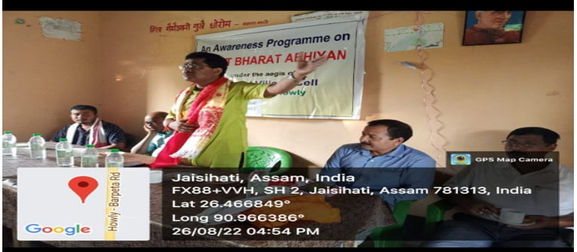

RAYPUR VILLAGE DETAILS
Name of the Village : Raypur
Block : Gobardhana
District : Barpeta
State : Assam
Pin Code 781325
Post Office : Barpeta
Assembly Constituency : Barnagar
Lok Sabha Constituency : Barpeta
Area of Village : 293.16 Hectres
Agricultural Area : 179.11 Hectres
Forest Area : Nil
Water Table : 40 feet
Area under water bodies : Nil
Communication Language : Assamese & Bengali
District Head Quarters : Barpeta (21 K.M towards East)
State Head Quarters : Dispur (Guwahati) (135 K.M towards East)
Literacy Rate | 80.07%
Total No. of Houses | 313
Total Population | 340
Male Population | 662
Female Population | 676
Nearest Cities | Barpeta

MAJOR FINDINGS OF THE SURVEY IN THE VILLAGE

Drinking water :
Most of the families use tube well as source of drinking water.

Transport facility :
The transport facility more or less is found to be satisfactory. Private vehicle, two-wheelers, e-rikshaw are are main means of travel within the village. The roads inside the village are mostly kuchha and sem-pucca road. Of course the connectivity road to the railway and bus station ia pucca.

Employment :
The main source of employment in the village is farming. Nearly 80% people are engaged in agricultural activities. A good number of people work as daily wage earner in the village. The percentage of Govt. service holder is found to be very poor i.e near about 2 % only.

Health Care :
There is a primary health centre in the village. The nearest Govt. civil hospital is 18 K.M. away from the village i.e, Barpeta Road civil Hospital.

Toilet Facility :
All the families have private toilet facilities of which some are pucaa and some are kuchha. 48% of families have been able to have the toilet facilities under Swachch Bharat.

Electricity :
All the households in the village are connected with electricity of which 35% have availed the BPL electricity connectivity. The electricity remains for 18 hours on an average per day.

Literacy :
The literacy rate in the village is found to be 80.07%.

Housing :
All the households have their own house of which 45% are pucca house, 25% is semi pucca and 30% is found to be kuchha.

MAJOR PROBLEMS
Following are the major problems in the village :-
  - Lack of Govt. transport facility
  - Lack of hospital facilities
  - Flood
  - Problem of sanitation
  - Lack of irrigation facility
  - Lack of cottage industry
  - Non recipients of other government schemes facilities.
  - Problem of unemployment

SUGGESTIONS FOR DEVELOPMENT
- Proper steps should be taken to increase the literacy rate of the people in the village.
- Cottage and small industry may be established for the purpose of eradication of educated unemployed youth.
- Irrigation facility should be provided for the farmers.
- Awareness camp should be organised to reduce the drop out students in the village.

VILLAGE SURVEY PHOTOGRAPH OF RAYPUR
v\