Fresher’s Cum Alumni Cum Get-together
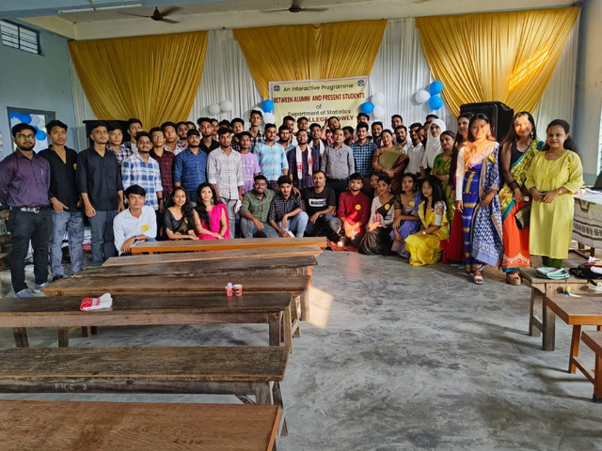

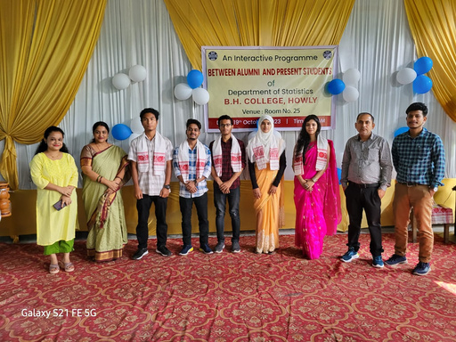
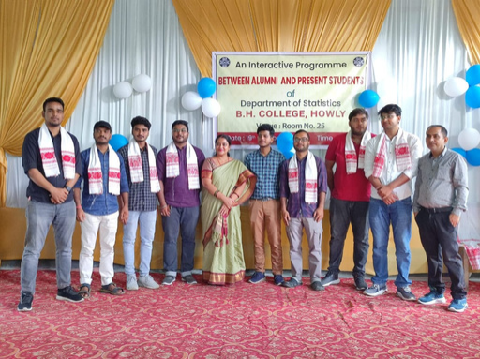

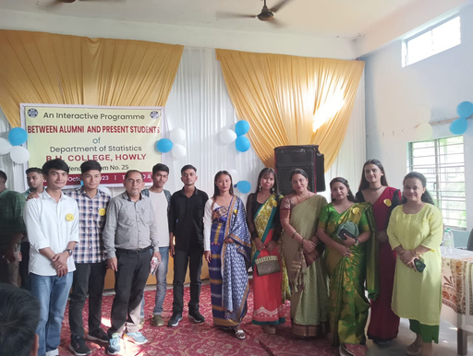

The freshers and get together was held on 19 October, 2023. A freshmen social is an experience that new college students cherish for a life time . It serves as an ice breaker by bringing together new and old students and hence creating friendship. This get toge the r witnessed present freshers, pass out students (senior) 6th and 4th semester students. All the teachers of the departmental along with principal sir and vice principal sir grace this occasion. This program was held with enjoyable performances like dance , attractive shayari and more . More over, Bhaskarjyoti Das, a pass out student performed a beautiful song which bring a very lively environment to the program. Then the freshers students introduced themselves very beautifully . Principal sir gave a valuable speech along with beautiful shayari . The presence of students from different batches starting from 2015 - 18 to 2023 - 24 made the program a very successfull and enjoyable . And lastly program was ended with a shayari from D r. C . K . Sarmah , HoD of the department.

