Best Practices of Assamese Department, B.H.College
Best Practices No.1
Title: "Verse Reflections: The Poem of the WeeK:
"Verse Reflections: The Poem of the Week" is a captivating practice carried out by the Assamese Department at B. H. College. This initiative involves displaying a carefully selected poem by a notable poet on a board situated in front of the department. The title encapsulates the essence of this practice, emphasizing the power of poetry to evoke thought, emotion, and contemplation.
Every week, the department curates a new poem, handpicked for its literary excellence, thematic depth, and relevance to the student's lives. The poem serves as a focal point, inviting passersby to pause, read, and engage with the beauty and wisdom expressed through the written word.
The selection of poems encompasses a diverse range of themes, styles, and poetic voices, ensuring that students are exposed to a rich tapestry of literary art. From classical verses to contemporary masterpieces, each poem offers a unique lens through which to explore the human experience and the depths of emotions.
The display of "The Poem of the Week" serves multiple purposes. Firstly, it fosters an appreciation for literature and encourages students to explore the world of poetry beyond their academic curriculum. It introduces them to renowned poets, both from their own culture and from around the world, expanding their horizons and nurturing a love for language and expression.
Moreover, the practice encourages reflection and introspection. The carefully chosen poems often touch upon universal themes such as love, nature, identity, and social issues, providing opportunities for students to connect with the profound messages conveyed through the poet's words. This engagement with poetry stimulates intellectual curiosity, critical thinking, and empathy, enabling students to gain a deeper understanding of themselves and the world around them.
Additionally, "Verse Reflections: The Poem of the Week" creates a sense of literary ambiance within the college environment. The beautifully displayed poem, accompanied by relevant visuals or illustrations, transforms the surroundings into a space where creativity and imagination thrive. It sparks conversations, ignites discussions, and encourages students and faculty alike to share their interpretations and personal connections to the poem.
In conclusion, "Verse Reflections: The Poem of the Week" is a delightful practice that brings the beauty and power of poetry to the forefront of the Assamese department at B.H. College. By showcasing carefully selected poems, this initiative inspires students to appreciate and explore the world of literature, while fostering introspection, critical thinking, and a sense of shared cultural heritage.

Best Practices No.2
Title: Collaborative Teaching: Bridging the Educational Gap in Schools of the adopted village.
Introduction: Education plays a vital role in shaping the future of individuals and societies. B. H. College is one of the excellent educational institutes of lower Assam. The college works for the educational improvement of its students and also undertakes some programs for the improvement of the students of the surrounding villages. There is a shortage of teachers in various subjects at the nearby High School. Various departments of the college take note of this and take the necessary steps. The Assamese Department is also providing services as far as possible.
Objectives:
Bridge the educational gap
Improve learning outcomes
Enhance professional development
Allocation of resources
Identifying areas of need

The Practice
An educational outreach program was organized by B.H. College, in collaboration with its esteemed professors, namely Dr. Renu Hazarika, Prof. Usha Das, and Dr. Prasanta Rabha. The program aimed to provide educational support and guidance to the students of Class X and IX at Barbarijhar High School, located in Barbarijhar village. Barbarijhar is one of the adopted villages of B.H. College, demonstrating its commitment to community development and fostering academic growth in the region. The primary objective of this educational outreach program was to enhance the educational experience of the students at Barbarijhar High School by leveraging the expertise and knowledge of the B.H. College professors. The program aimed to provide academic support, guidance, and motivation to the students, empowering them to excel in their studies and future endeavors. The professors delivered inspiring motivational talks to encourage the students to set ambitious goals and strive for excellence. They shared their own experiences and success stories, emphasizing the importance of perseverance, dedication, and hard work. The talks aimed to instill a sense of motivation and self-belief in the students, helping them overcome obstacles and reach their full potential
Program Details:

Class at Barbarijhar High School on 27-05-2023
The Department of Assamese', B. H. College, Howly arranges a class in Barbarijhar High School, which is located in the village of Barbarijhar and situated at a distance of 0.5 KM from B. H. College, today on 27-05-2022 at 11.00 AM. Usha Das, Associate Professor, Department of Assamese, B. H. College, Howly teaches the subject Assamese (MIL) to the students of class X and gives an idea of the art of literature. She explains the lesson 'Aranyar katha'. Head Mistress Rupali Das, M.Sc, B.Ed. makes the necessary arrangements for the class. Most of the students are found to be very attentive and interactive. A total of 56 nos. of students were present in the class.
https://www.bhcollege.ac.in/multiple_depart.php?id=160
Class at Barbarijhar High School on 29-05-2023

Dr. Renu Hazarika, HOD, Department of Assamese, and Dr. Prasanta Rabha Howly taught the subject Assamese (MIL) on 29-05-2022 at 11.00 A.M. to the students of classes X and IX. They conducted interactive academic sessions, covering various subjects included in the curriculum for Class X and IX. They used innovative teaching methods and engaging teaching aids to make the sessions interesting and informative. The professors focused on clarifying concepts, providing real-life examples, and addressing students' queries to ensure a thorough understanding of the topics discussed. Dr. Hazarika explained the poem 'Kanair Chaturi'. Dr. Prasanta Rabha taught the students of class IX. Head Mistress Rupali Das, M.Sc, B.Ed. made the necessary arrangements for the class.
https://www.bhcollege.ac.in/multiple_depart.php?id=165

Most of the students were found to be very attentive and interactive. A total of 120 nos. of students from both classes were present in the class.
Class at Barbarijhar High School on 30-05-2023
Usha Das, Associate Professor, Department of Assamese, B. H. College, Howly teaches the subject Assamese (MIL) to the students of class X on 30-05-2022 at 1.00 PM and gives an idea of the art of literature. She explains the lesson 'Aranyar katha'. Head Mistress Rupali Das, M.Sc, B.Ed. makes the necessary arrangements for the class. Most of the students are found to be very attentive and interactive. A total of 60 nos. of students were present in the class.
https://www.bhcollege.ac.in/multiple_depart.php?id=163
Class at Barbarijhar High School on 07-06-2023
Usha Das, Associate Professor, Department of Assamese, B. H. College, Howly teaches the subject Assamese (MIL) to the students of class X on 07-06-2023 at 1.00 PM and gives an idea of the art of literature. She finishes the lesson 'Aranyar katha'. Head Mistress Rupali Das, M.Sc, B.Ed. makes the necessary arrangements for the class. Most of the students are found to be very attentive and interactive. A total 60 nos. of students were present in the class
Evidence of success
The students have become interested in their studies.
Their creative skills and personality development have been enhanced.
Improvement of academic performance.
Increase in enrollment.
Problems encountered :
Most of the students are from poor families and have no proper environment for education in the families.
Most guardians engage their children in cultivation.
Female education is repelled by some guardians.
Conclusion
The college's initiative to adopt villages and organize such educational outreach programs showcases its strong commitment to community development and academic empowerment. It is a testament to their belief in the power of education and their dedication to nurturing the potential of young minds.
The success of this program serves as an inspiration for future endeavors, encouraging other educational institutions and community members to come together and make a positive impact on the lives of students in underprivileged areas
The educational outreach program organized by B.H. College professors at Barbarijhar High School proved to be a resounding success. The program not only provided valuable academic support but also instilled a sense of motivation, self-belief, and determination in the students. It served as a stepping stone towards their holistic development and encouraged them to strive for excellence in all aspects of life.
Best Practices No.3
Title: "Embracing Cultural Heritage: Folk Dance Workshops at B. H. College"
Description: The practice of organizing folk dance workshops at B H College can be considered a best practice for the department, as it offers numerous benefits to the students. The title "Embracing Cultural Heritage: Folk Dance Workshops at B H College" aptly captures the essence of this practice.
The workshops aim to promote and preserve traditional folk dances, providing students with a unique opportunity to explore and engage with their cultural heritage. By immersing themselves in these art forms, students gain a deeper understanding of their roots, fostering a sense of pride and appreciation for their cultural traditions.
During the workshops, students learn various folk dances from different regions, enhancing their knowledge of diverse cultural practices. Expert instructors are invited to teach and guide the students, ensuring that they receive quality training and exposure to authentic dance forms.
Engaging in folk dance workshops offers numerous advantages. Firstly, it promotes physical fitness and coordination as students learn intricate dance moves, improving their stamina, balance, and flexibility. Secondly, it enhances creativity and self-expression, allowing students to explore their artistic abilities and develop their unique style.
Furthermore, these workshops foster teamwork and collaboration, as students often perform in groups, requiring them to synchronize their movements and work together to create a cohesive performance. This builds valuable interpersonal skills and encourages a sense of camaraderie among the participants.
In addition, folk dance workshops provide a platform for students to showcase their talents and perform in front of an audience. This boosts their confidence and stage presence, helping them develop essential skills for public speaking and performing arts.
www.bhcollege.ac.in/multiple_depart.php?id=199

Overall, the practice of organizing folk dance workshops at B H College is a commendable initiative that not only preserves cultural heritage but also benefits students holistically. It enriches their understanding of diverse traditions, promotes physical fitness and creativity, encourages teamwork, and instills a sense of pride in their cultural identity.

No.4
Title of the Practice: Knowledge of Information and Communication Technology( ICT) for the benefit of the students of the Assamese Department.

Information and technology have become, within a very short time, one of the basic building blocks of modern society. It has become more useful for students. To explore the knowledge of the students, B. H. College installed several numbers of Interactive panels. Teachers and students have got an opportunity to exchange their views by using ICT. It is taught at the beginning of the session by the teachers of the Assamese Department or other expert persons.
Objectives
1. Teaching the students to keep up with the times.
2. To teach the various techniques of ICT to support the curriculum.
3. To make the students confident and capable by using ICT.
4. To develop creativity among students.

The Practice
PowerPoint Presentation:
Nowadays seminar presentation is necessary for each curriculum. It becomes fruitful by using PowerPoint. Therefore students are taught how to prepare PowerPoint. A syllabus topic is given to the students and they are instructed to prepare power point of that topic. This can help in making education more interactive and attract students towards the modified version of offline studying.
https://www.bhcollege.ac.in/multiple_depart.php?id=100

Digital Platform and Assamese Language

Nowadays digital media is one of the most discussed and influential tools of the 21st century on which modern society, civilization, and culture are based. Similarly, digital media is now the appropriate medium to express how rich culture and language are. Therefore, the students are trained by experienced persons on how to use the Assamese language in digital media.
https://www.bhcollege.ac.in/multiple_depart.php?id=108

Online Resources:
Curate and provide access to a wide range of online resources, such as e-books, educational websites, digital libraries, and open educational resources. These resources can supplement classroom instruction and promote self-directed learning. The college library provides students with the facilities of N-List. N-List provides students with access to a vast collection of e-resources, including e-books, e-journals, databases, and other scholarly content.
Evidence of success
As a result, the students were able to give seminars successfully. Many of them have started doing Assamese DTP on a commercial basis. The projects they were given to do improved by using online materials. The students were digitally soun in other areas also.
Problems Encountered
Most students do not have a computer at home.
Most places do not have internet.

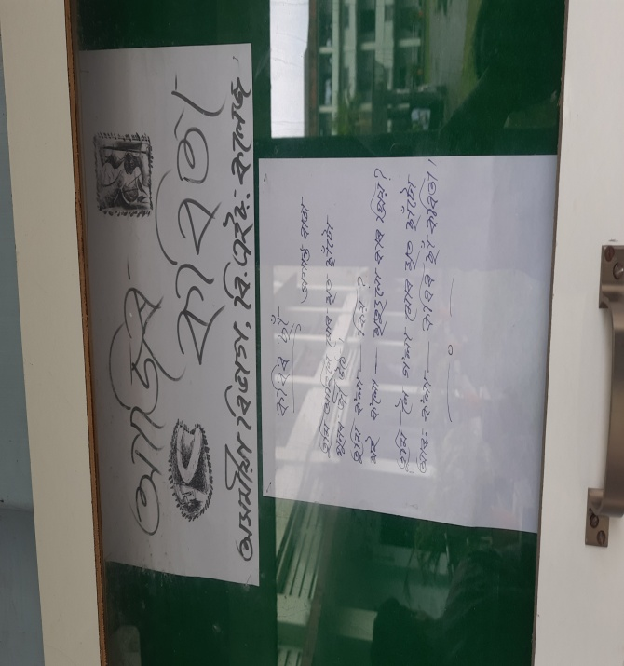
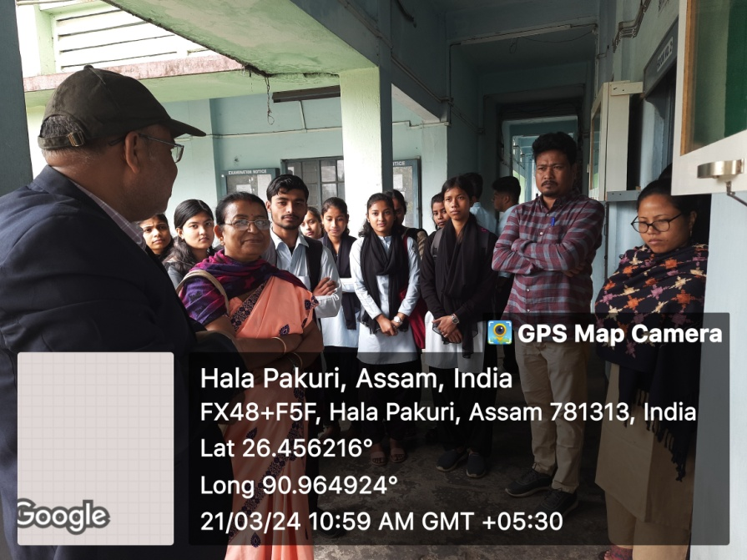
Title: Best Practice and Student Mentorship Programme.

Objective:
The primary objective of our department's home visitation and student mentorship program is to foster a supportive environment conducive to the academic and personal growth of our students. By engaging directly with both students and their parents or guardians, we aim to identify and address any challenges or concerns that may hinder their educational journey. Additionally, through the establishment of mentor-mentee relationships, we seek to provide personalized guidance and support to ensure each student's success.

Outcome:
Through the implementation of this best practice, we have observed several positive outcomes:

Improved Parental Engagement: Home visits facilitate direct communication between educators and parents, leading to increased parental involvement in their child's education. This heightened collaboration enables parents to better understand their child's progress and academic needs, fostering a stronger partnership between home and school.

Enhanced Student Support: The presence of student mentors within our program enables us to gain valuable insights into the individual needs and circumstances of each student. By leveraging peer support, we can offer targeted assistance and encouragement tailored to the specific challenges faced by students, thereby enhancing their academic performance and overall well-being.

Early Intervention and Support: By proactively identifying potential issues or obstacles through home visits and mentorship, we can intervene early to provide necessary support and resources. Whether it be academic struggles, social-emotional concerns, or family-related challenges, our program allows us to address these issues promptly, mitigating their impact on student success.

Holistic Development: Through our holistic approach to student support, encompassing both academic and personal growth, we aim to cultivate well-rounded individuals equipped with the skills and resilience needed to thrive in both their academic pursuits and future endeavors.

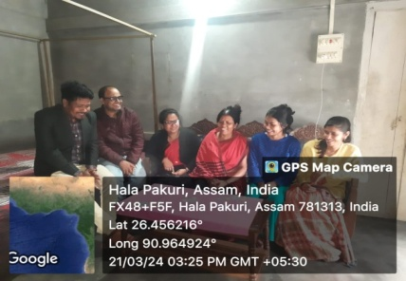
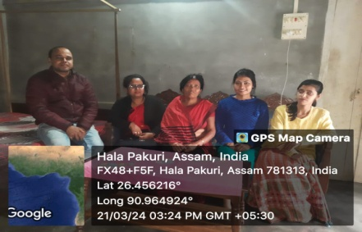
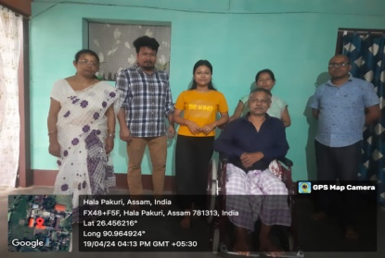
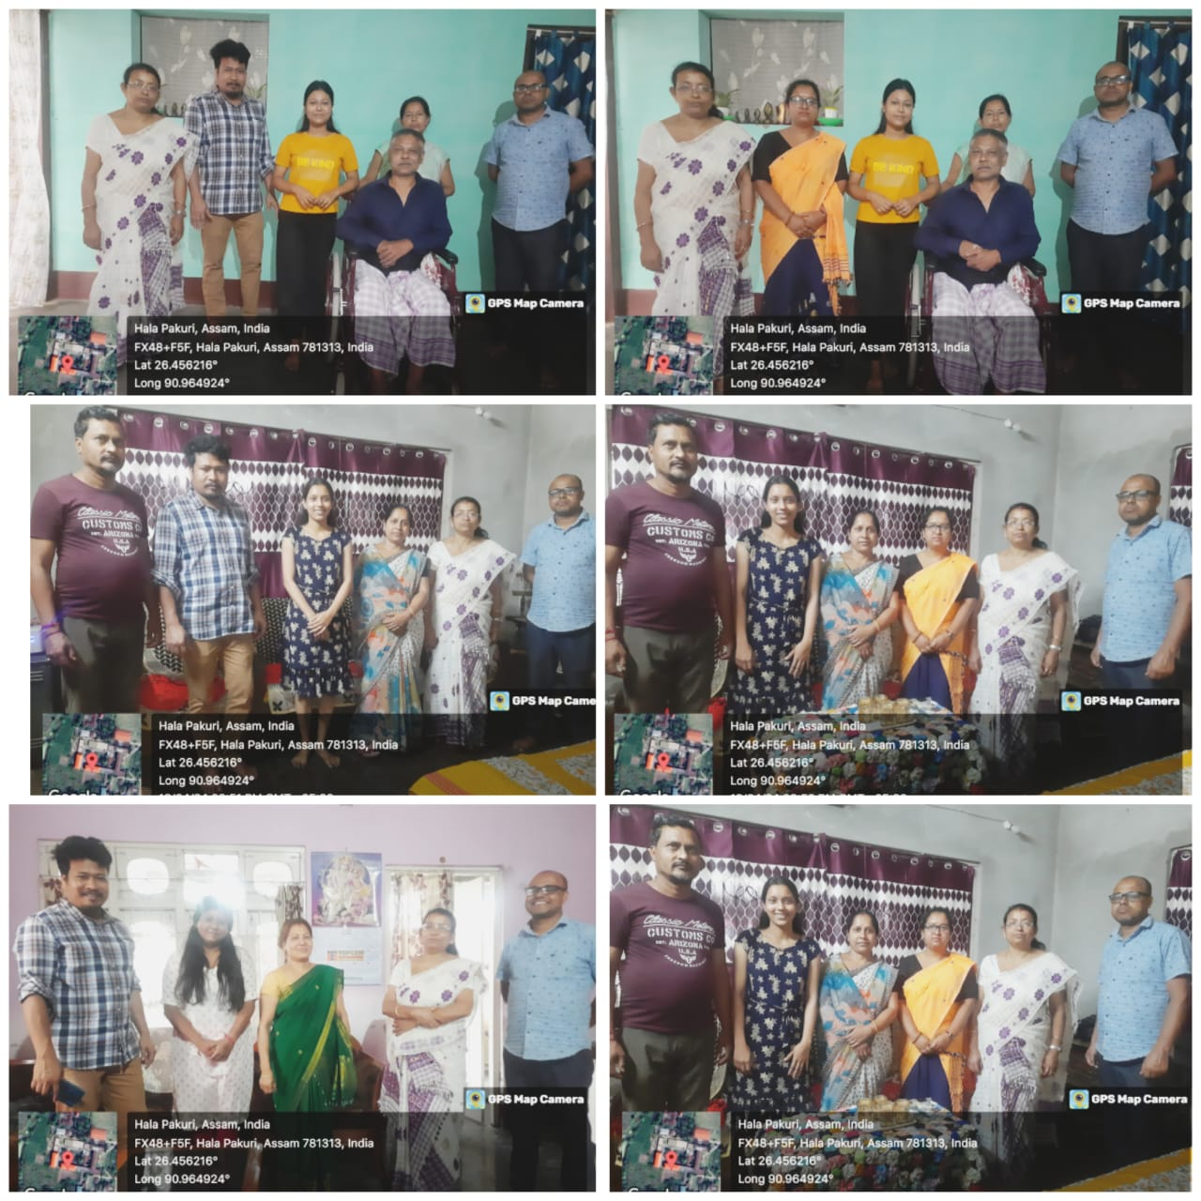
In conclusion, our department's home visitation and student mentorship program exemplify our commitment to the holistic development and success of our students. By fostering strong partnerships with parents, providing personalized mentorship, and intervening proactively, are able to create a supportive learning environment where every student has the opportunity to express their needs.
