BOOKS DONATION: Apart from the central library, our Botany department has a departmental library catering to the needs of faculty and students. The library is equipped with more than 350 books which cover the syllabus of UG course and all the students and faculty utilized the books in the library for their study. The objectives of the departmental library are to promote the reference books among the students. Maximum 3 books are issued to each student for seven days. The library rule is that the issued books have to return in time. After final exam, alumni and most of the 6th semester student donated book every year to the department library.
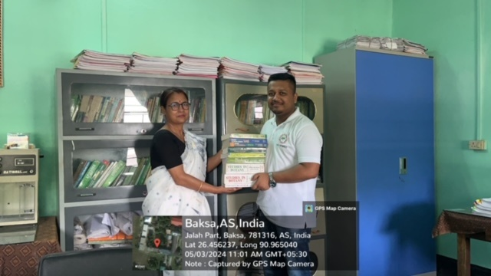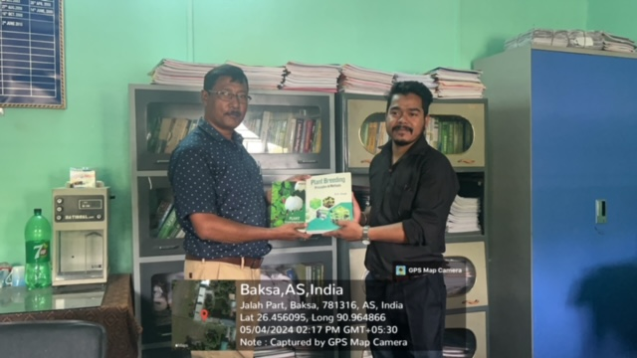
Books donated by Alumni

