B H College Statistics Department



**Alumni Name and Qualification & Job Description :**

### **Sl No : 1 - Mahammadul Hassan Ahmed**

**Name:-** Mahammadul Hassan Ahmed

**Batch :-** 2015 - 2018

**Job Title / Job Description:-** Assam Police Radio Organisation

**Job location:-** 28th APBN Howly, Barpeta.

**Working from:-** 05/06/2022 - Present

|  |  |
| --- | --- |

### **Sl No : 2 - Dimpumoni Saud**

**Name :** Dimpumoni Saud

**Batch :-** 2015 - 2018

**Job Description / Business Description :**  Mandal (Bashundhara)

**Job Location :** Sarthebari Revenue Circle

**Working From :** 2021 - Present

|  |  |
| --- | --- |

### **Sl No : 3 - Nikumani Choudhury**

**Name :** Nikumani Choudhury

**Batch :-** 2015 - 2018

**Qualification :** M.Sc IT (Bodoland University) -2021

**Job Description / Business Description :**  Subject Teacher

**Job Location :** Buds Academy Sorbhog

**Working From :** 2021 - Present

| I - Card Buds Academy | MSc Certificate |
| --- | --- |

### **Sl No : 4 - Bappi Sutradhar**

**Name -** Bappi Sutradhar

**Batch :-** 2015 - 2018

**Job Title / Job Description -** Government E marketplace operator

**Qualification -** M.Sc Geography (IGNOU) - Pursuing

**Post -** Senior Tender executive

**Company Name -** vee solution pvt ltd

**Job location -** New Delhi (work from home )

**Work from :** 01/04/2020

|  |  |
| --- | --- |

### **Sl No : 5 - Abhik Basak**

**Name -** Abhik Basak

**Batch :-** 2015 - 2018

**Qualification -** M.Sc Geography (IGNOU) - Pursuing

**Job Title / Job Description -** self employed

**Job location -** Barpeta Road

**Working from -** 2022

|  |  |
| --- | --- |

### **Sl No : 6 - Saheb Saha**

**Name :** Saheb Saha

**Batch :-** 2015 - 2018

**Qualification -** M.Sc Statistics (Gauhati University)

**Job Description / Business Description :**  Assistant Teacher

**Place :** Bongaigaon

**Date of Joining :** 01/02/2023

|  |  |
| --- | --- |
|  |  |

**Sl No : 7 - Nayanjyoti Das**

**Name :** Nayanjyoti DAS

**Batch :-** 2015 - 2018

**Qualification -** M.Sc Statistics (Tripura University) - Pursuing

|  |  |
| --- | --- |

### **Sl No : 8 - Bishal Dev Saha**

**Name :** Bishal Dev Saha

**Batch :-** 2016 - 2019

**Qualification -** M.Sc. in Statistics, M.A. in Economics and B. Ed

**Job Description / Business Description :**  Assistant Teacher in Department of Statistics, B.H. College, Howly

**Place :** Hala Pakuri

**Date of Joining :**

|  |  |
| --- | --- |

### **Sl No : 9 - Bituraj Das**

**Name :** Bituraj Das

**Batch :-** 2016 - 2019

**Qualification -** B.Sc. in Statistics and Diploma in Stenography

**Job Description / Business Description :**  Field Officer, DDMA

**Place :** Bongaigaon

**Date of Joining :**

|  |  |
| --- | --- |

### **Sl No : 10 - Hachibul Islam**

**Name :** Hachibul Islam

**Batch :-** 2016 - 2019

**Qualification -** M.Sc. in Statistics

**Job Description / Business Description :**

**Place :**

**Date of Joining :**

|  |  |
| --- | --- |

### **Sl No : 11 - Joydev Singha**

**Name :** Joydev Singha

**Batch :-** 2016 - 2019

**Qualification -** B. Ed, Masters in Education (Pursuing)

**Job Description / Business Description :**  Assistant Teacher in Aryabhatta Academy

**Place :** North Barpeta Road

**Date of Joining :**

|  |  |
| --- | --- |

### **Sl No : 12 - Pallab Saha**

**Name :** Pallab Saha

**Batch :-** 2016 - 2019

**Qualification -** B.Sc in Statistics

**Job Description / Business Description :**  Placement Coordinator at AISECT SKP Barpeta Road

**Place :** Barpeta Road

**Date of Joining :** 2020

|  |  |
| --- | --- |

### **Sl No : 13 - Prabal Talukdar**

**Name :** Prabal Talukdar

**Batch :-** 2016 - 2019

**Qualification -** B.Sc in Statistics

**Job Description / Business Description :**  Junior District Administrative Assistant

**Place :** Pathsala

**Date of Joining :**

|  |  |
| --- | --- |

### **Sl No : 14 - Suravi Nath**

**Name :** Suravi Nath

**Batch :-** 2016 - 2019

**Qualification -** M.Sc. in Statistics, Ph. D. in Statistics in Cotton University (Pursuing)

**Job Description / Business Description :**

**Place :**

**Date of Joining :**

|  |  |
| --- | --- |

### **Sl No : 15 - Biju Roy**

**Name :** Biju Roy

**Batch :-** 2017 - 2020

**Qualification -** B.Sc. in Statistics

**Job Description / Business Description :**  Teacher in Govt. School

**Place :**

**Date of Joining :**

|  |  |
| --- | --- |

### **Sl No : 16 - Jupitora Pathak**

**Name :** Jupitora Pathak

**Batch :-** 2017 - 2020

**Qualification -** B.Sc. in Statistics, B. Ed (Pursuing)

**Job Description / Business Description :**

**Place :**

**Date of Joining :**

| I Card |  |
| --- | --- |

### **Sl No : 17 - Preetideep Gope**

**Name :** Preetideep Gope

**Batch :-** 2017 - 2020

**Qualification -** M. Sc. In Statistics in Cotton University(Pursuing)

**Job Description / Business Description :**

**Place :**

**Date of Joining :**

|  |  |
| --- | --- |

**Sl No :18 - Manas Pratim Das**

**Name :** Manas Pratim Das

**Batch :-** 2018 - 2021

**Qualification -** B. Sc. In Statistics

**Job Description / Business Description :**  Chowkidar(MTS)

**Place :** Chapakhowa, Sadiya, Tinsukia

**Date of Joining :** 01/06/2023

|  |  |
| --- | --- |

### **Sl No : 19 - Sanidul Islam**

**Name :** Sanidul Islam

**Batch :-** 2018 - 2021

**Qualification -** M. Sc. In Statistics - (Pursuing)

**Job Description / Business Description :**

**Place :**

**Date of Joining :**

|  |  |
| --- | --- |

### **Sl No : 20 - Bigrai Boro**

**Name :** Bigrai Boro

**Batch :-** 2018 - 2021

**Qualification -** M.C.A - (Pursuing)

**Job Description / Business Description :**

**Place :**

**Date of Joining :**

|  |  |
| --- | --- |

### **Sl No :21 - Bhaskar Jyoti Das**

**Name :** Bhaskar Jyoti Das

**Batch :-** 2018 - 2021

**Qualification -** B. Sc. In Statistics

**Job Description / Business Description :**  Block Level Fellow

**Place :** Goreswor Block, Tamulpur

**Date of Joining :** 31/10/2022

|  |  |
| --- | --- |

### **Sl No : 22- Sanjay Kherkatary**

**Name :** Sanjay Kherkatary

**Batch :-** 2018 - 2021

**Qualification -** B. Sc. In Statistics

**Job Description / Business Description :**  Constable (UB)/3335

**Place :** Guwahati

**Date of Joining :** 25/05/2023

|  |  |
| --- | --- |

### **Sl No : 23 - Giyas Uddin**

**Name :** Giyas Uddin

**Batch :-** 2018 - 2021

**Qualification -** M. Sc. In Statistics - Pursuing

**Job Description / Business Description :**

**Place :**

**Date of Joining :**

|  |
| --- |

### **Sl No : 24 - Parbit Raj Srivastwa**

**Name :** Parbit Raj Srivastwa

**Batch :-** 2018 - 2021

**Qualification -** BS In Data Science And Application

**Job Description / Business Description :**

**Place :**

**Date of Joining :**

|  |
| --- |

### **Sl No : 25 -Pralay Das**

**Name :** Pralay Das

**Batch :-** 2019 - 2022

**Qualification -** BSc. in statistics

**Job Description / Business Description :MTS**

**Place :** Dudhnoi,Goalpara

**Date of Joining : 23/06/23**

|  |  |
| --- | --- |

### **Sl No :26 -Nihar Pathak**

**Name :** Nihar Pathak

**Batch :-** 2019 - 2022

**Qualification -** BSc. in Statistics

**Job Description / Business Description :Pursing M.Sc in statistics**

**Place :** Cotton University, Guwahati

**Date of Joining :**

|  |  |
| --- | --- |

### **Sl No :27 -Arjun Barman**

**Name :** Arjun Barman

**Batch :-** 2019 - 2022

**Qualification -** BSc. in Statistics

**Job Description / Business Description :Office Peon**(MTS)

**Place :**Office of the Executive Engineer,Bajali W.R Division::Pathsala

**Date of Joining : 2023**

|  |  |
| --- | --- |

### **Sl No :28 -Pinki Brahma**

**Name :** Pinki Brahma

**Batch :-** 2019 - 2022

**Qualification -** BSc. in Statistics

**Job Description / Business Description pursuing MSc in Cotton University**

**Place : Guwahati**

**Date of Joining :**

|  |
| --- |

**Sl No. 29 Partha Pratim Das**

**Batch: 2021-2024**

**Qualification -** BSc. in Statistics

**Job Description: MSc in Gauhati University**

**Place : Guwahati**

**Date of Joining: 2024**



**Sl No. 30 Ankita Das**

**Batch: 2021-2024**

**Qualification -** BSc. in Statistics

**Job Description: MSc in Bhattadev University**

**Place : Guwahati**

**Date of Joining: 2024**

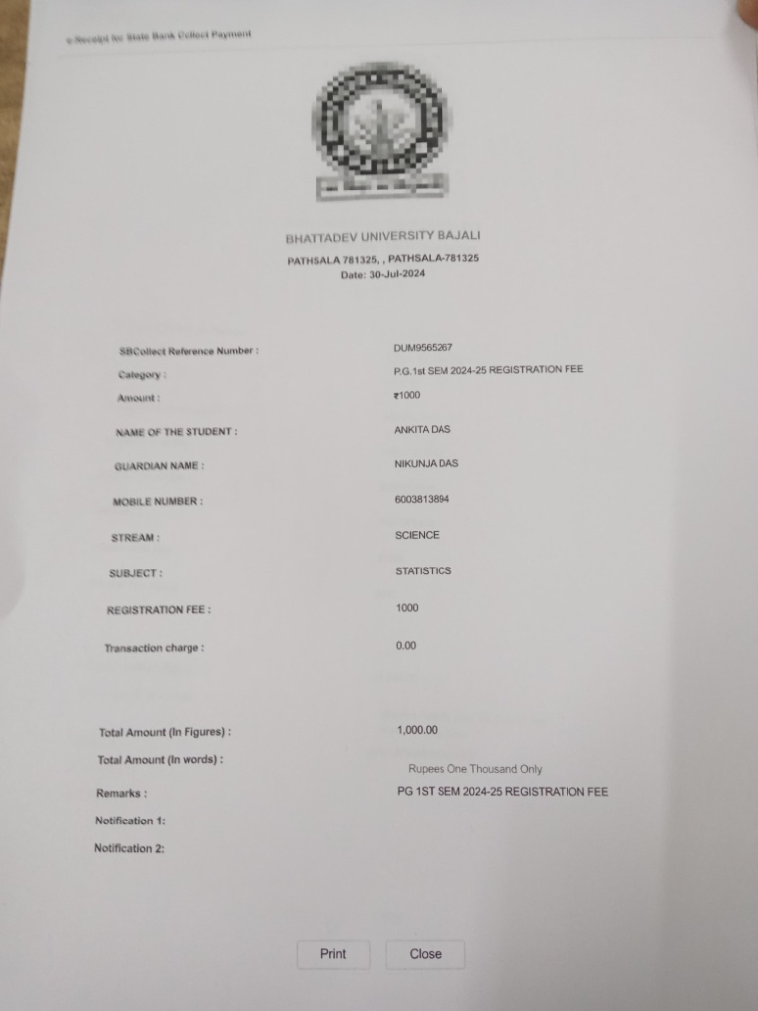

**Sl No. 30 Rick Paul**

**Batch: 2021-2024**

**Qualification -** BSc. in Statistics

**Job Description: MSc in Bhattadev University**

**Place : Guwahati**

**Date of Joining: 2024**

