B H College Statistics Department


Alumni Name and Qualification & Job Description :

Sl No : 1 - Mahammadul Hassan Ahmed
Name:- Mahammadul Hassan Ahmed
Batch :- 2015 - 2018
Job Title / Job Description:- Assam Police Radio Organisation
Job location:- 28th APBN Howly, Barpeta.
Working from:- 05/06/2022 - Present

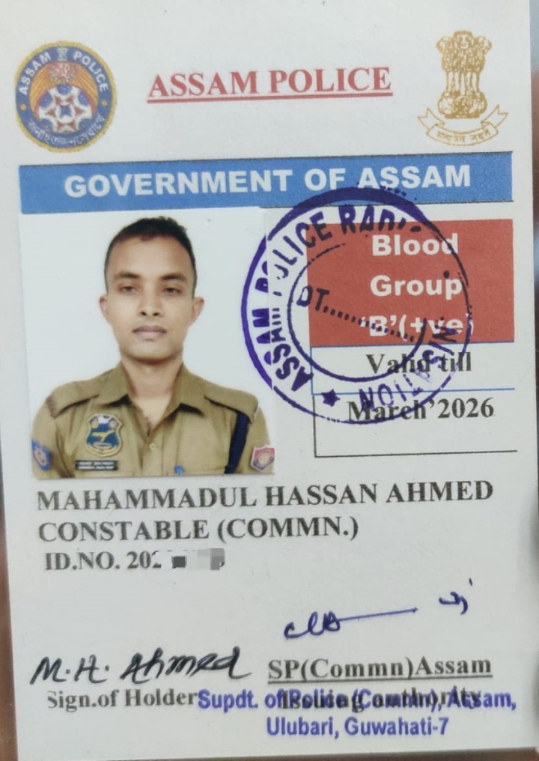

Sl No : 2 - Dimpumoni Saud
Name : Dimpumoni Saud
Batch :- 2015 - 2018
Job Description / Business Description : Mandal (Bashundhara)
Job Location : Sarthebari Revenue Circle
Working From : 2021 - Present

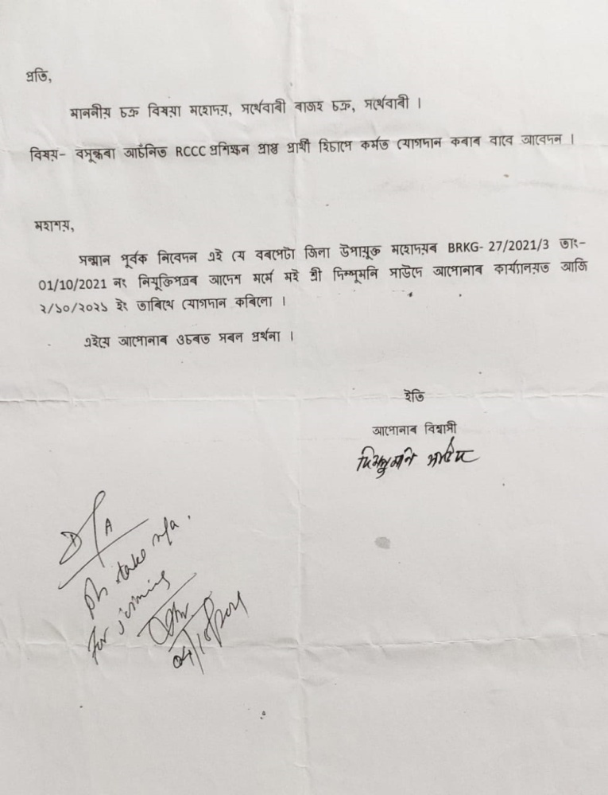

Sl No : 3 - Nikumani Choudhury
Name : Nikumani Choudhury
Batch :- 2015 - 2018
Qualification : M.Sc IT (Bodoland University) -2021
Job Description / Business Description : Subject Teacher
Job Location : Buds Academy Sorbhog
Working From : 2021 - Present

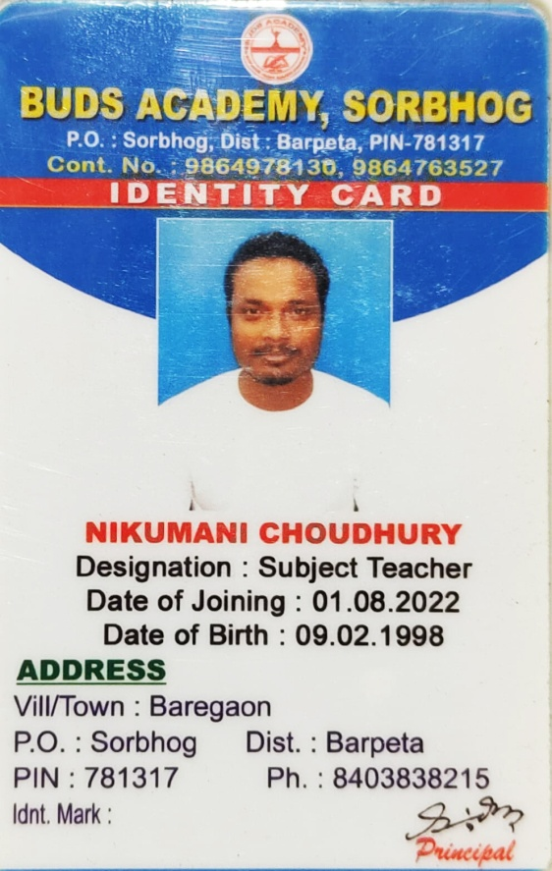  I - Card Buds Academy | 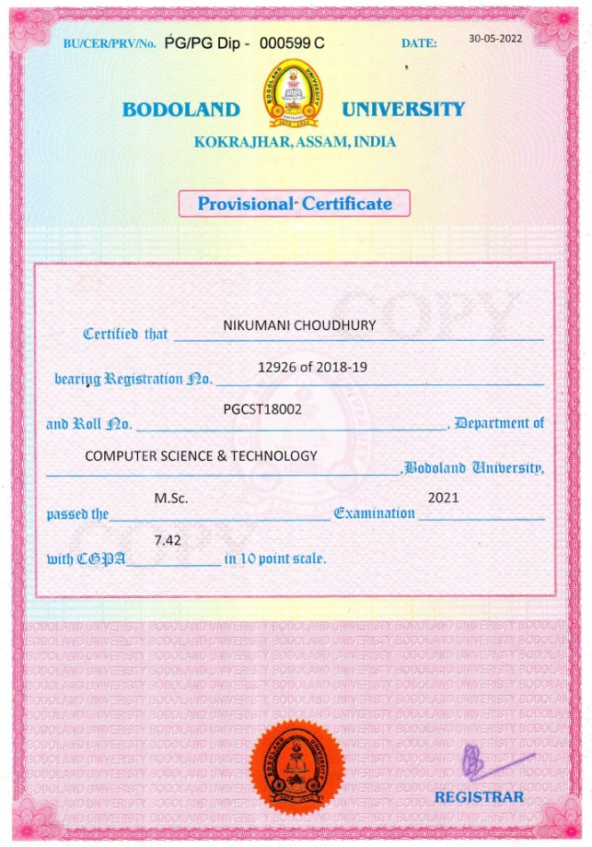  MSc Certificate

Sl No : 4 - Bappi Sutradhar
Name - Bappi Sutradhar
Batch :- 2015 - 2018
Job Title / Job Description - Government E marketplace operator
Qualification - M.Sc Geography (IGNOU) - Pursuing
Post - Senior Tender executive
Company Name - vee solution pvt ltd
Job location - New Delhi (work from home )
Work from : 01/04/2020

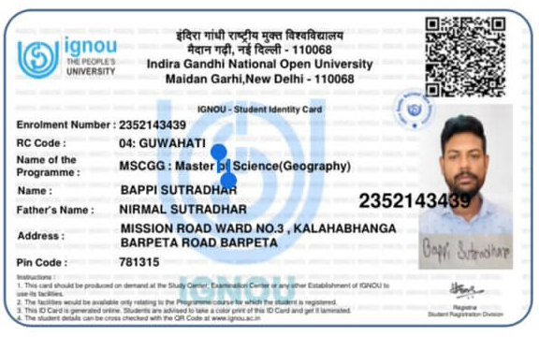 | 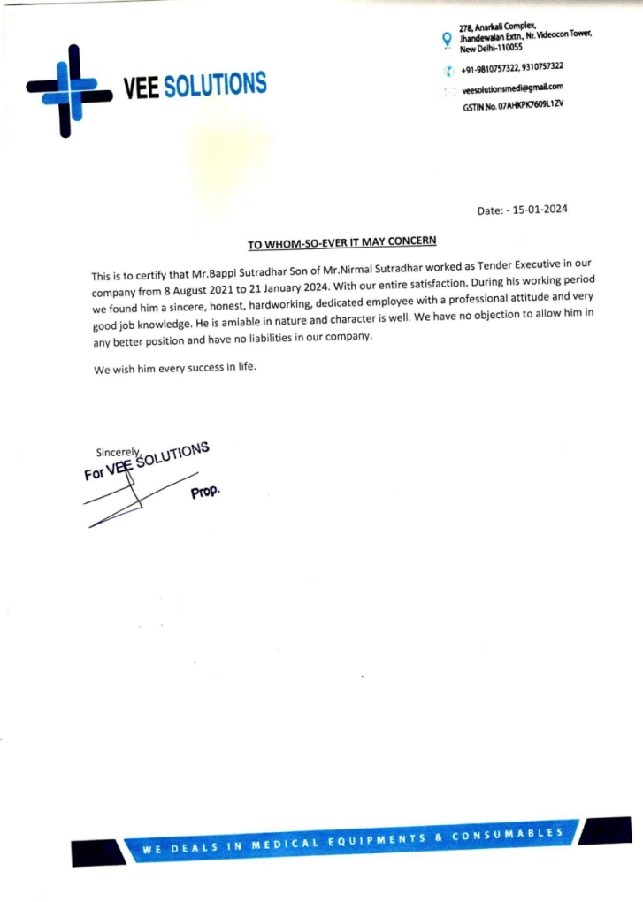

Sl No : 5 - Abhik Basak
Name - Abhik Basak
Batch :- 2015 - 2018
Qualification - M.Sc Geography (IGNOU) - Pursuing
Job Title / Job Description - self employed
Job location - Barpeta Road
Working from - 2022

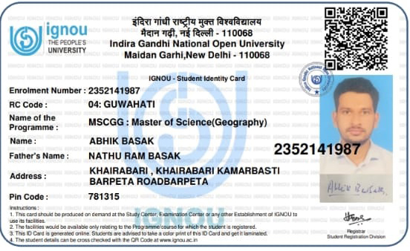

Sl No : 6 - Saheb Saha
Name : Saheb Saha
Batch :- 2015 - 2018
Qualification - M.Sc Statistics (Gauhati University)
Job Description / Business Description : Assistant Teacher
Place : Bongaigaon
Date of Joining : 01/02/2023

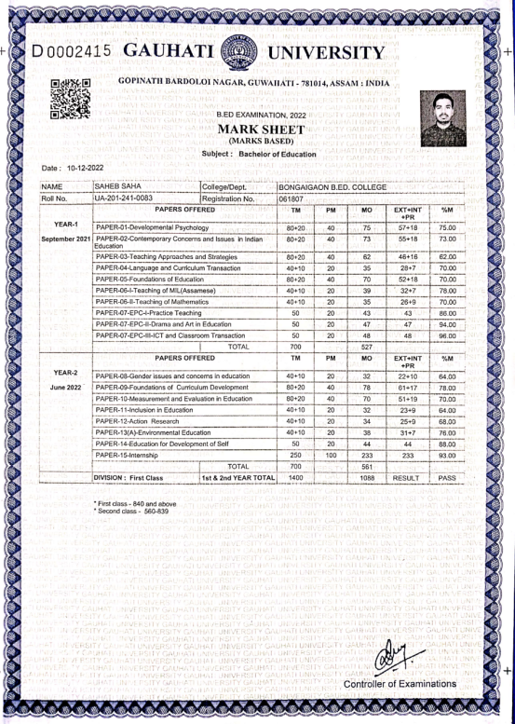 | 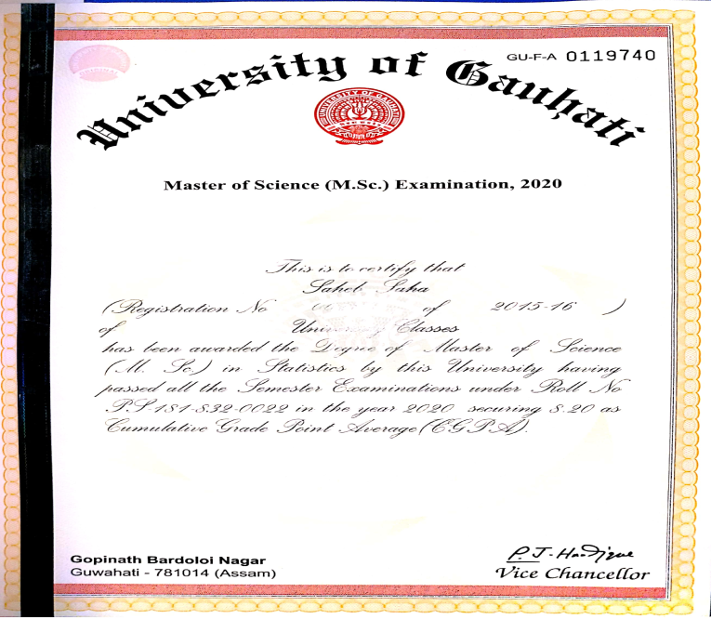
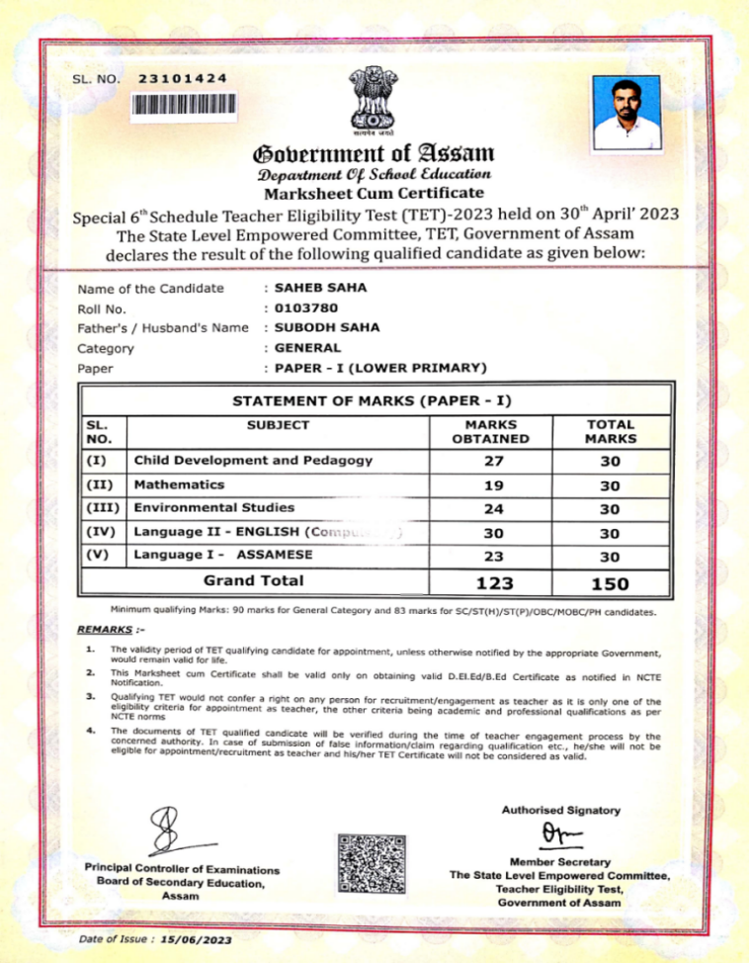 | 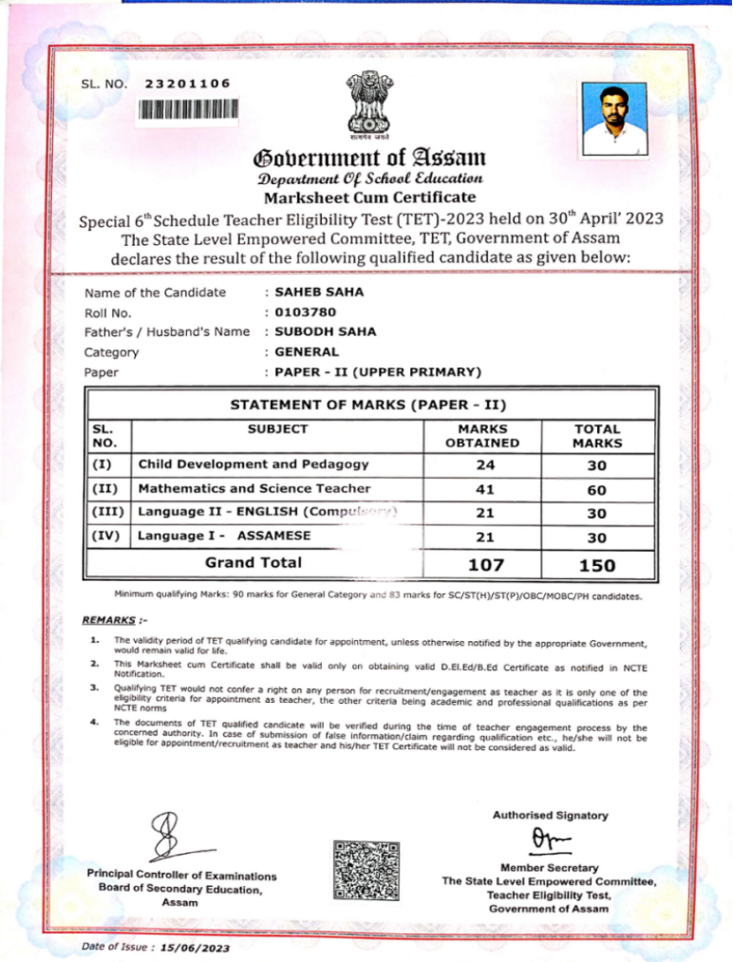

Sl No : 7 - Nayanjyoti Das
Name : Nayanjyoti DAS
Batch :- 2015 - 2018
Qualification - M.Sc Statistics (Tripura University) - Pursuing

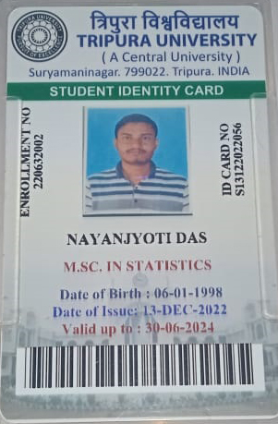

Sl No : 8 - Bishal Dev Saha
Name : Bishal Dev Saha
Batch :- 2016 - 2019
Qualification - M.Sc. in Statistics, M.A. in Economics and B. Ed
Job Description / Business Description : Assistant Teacher in Department of Statistics, B.H. College, Howly
Place : Hala Pakuri
Date of Joining :

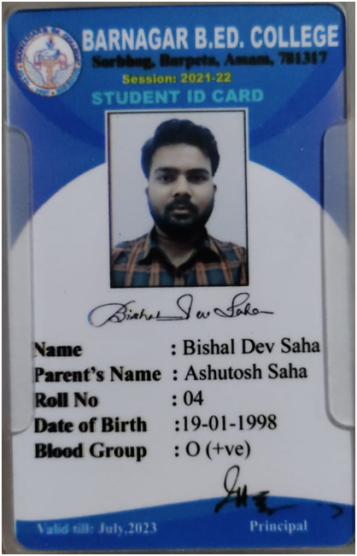

Sl No : 9 - Bituraj Das
Name : Bituraj Das
Batch :- 2016 - 2019
Qualification - B.Sc. in Statistics and Diploma in Stenography
Job Description / Business Description : Field Officer, DDMA
Place : Bongaigaon
Date of Joining :

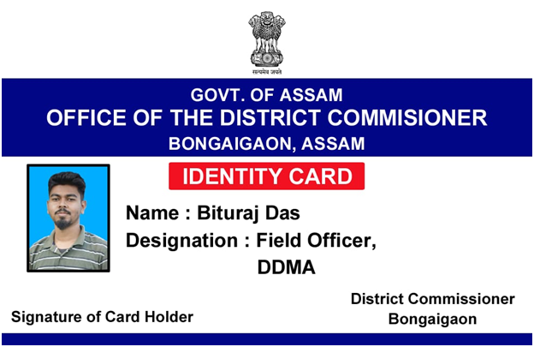

Sl No : 10 - Hachibul Islam
Name : Hachibul Islam
Batch :- 2016 - 2019
Qualification - M.Sc. in Statistics
Job Description / Business Description :
Place :
Date of Joining :

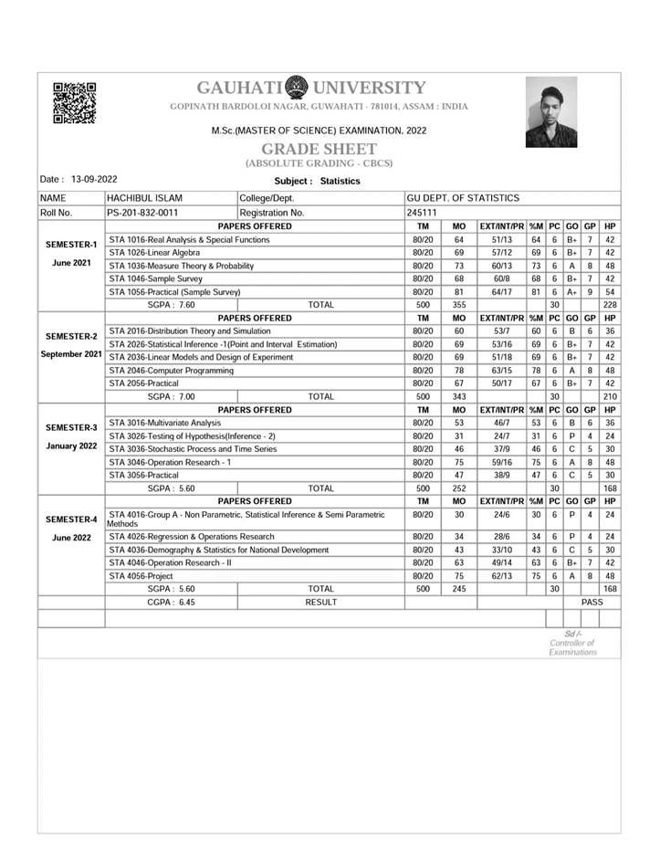

Sl No : 11 - Joydev Singha
Name : Joydev Singha
Batch :- 2016 - 2019
Qualification - B. Ed, Masters in Education (Pursuing)
Job Description / Business Description : Assistant Teacher in Aryabhatta Academy
Place : North Barpeta Road
Date of Joining :

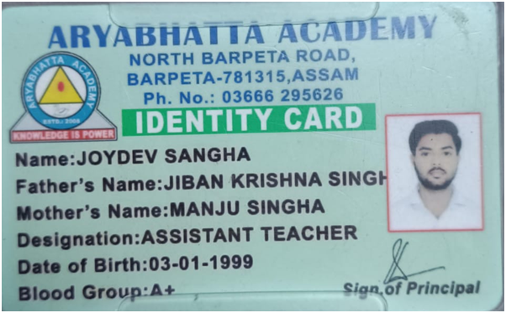 | 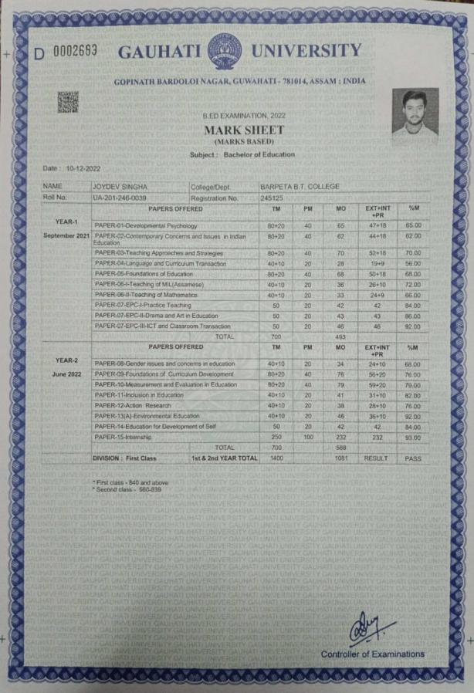

Sl No : 12 - Pallab Saha
Name : Pallab Saha
Batch :- 2016 - 2019
Qualification - B.Sc in Statistics
Job Description / Business Description : Placement Coordinator at AISECT SKP Barpeta Road
Place : Barpeta Road
Date of Joining : 2020



Sl No : 13 - Prabal Talukdar
Name : Prabal Talukdar
Batch :- 2016 - 2019
Qualification - B.Sc in Statistics
Job Description / Business Description : Junior District Administrative Assistant
Place : Pathsala
Date of Joining :

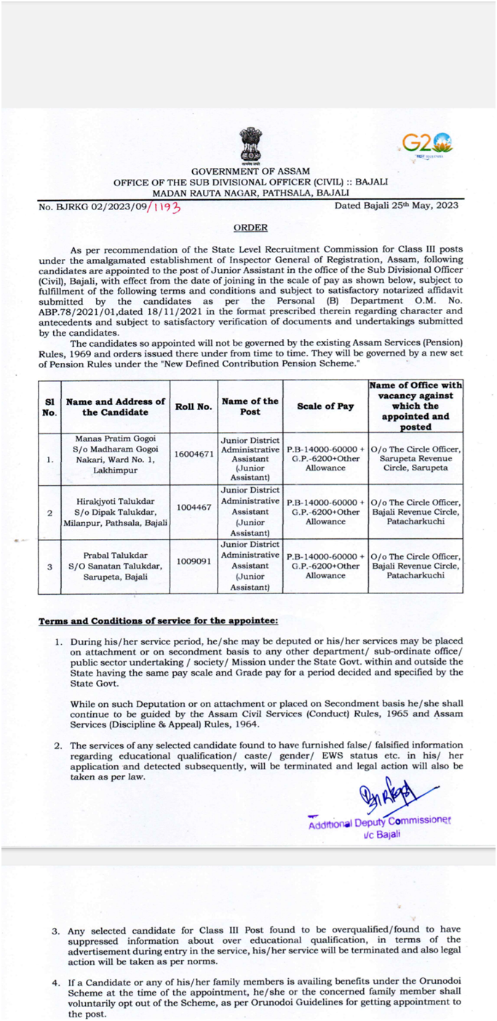

Sl No : 14 - Suravi Nath
Name : Suravi Nath
Batch :- 2016 - 2019
Qualification - M.Sc. in Statistics, Ph. D. in Statistics in Cotton University (Pursuing)
Job Description / Business Description :
Place :
Date of Joining :

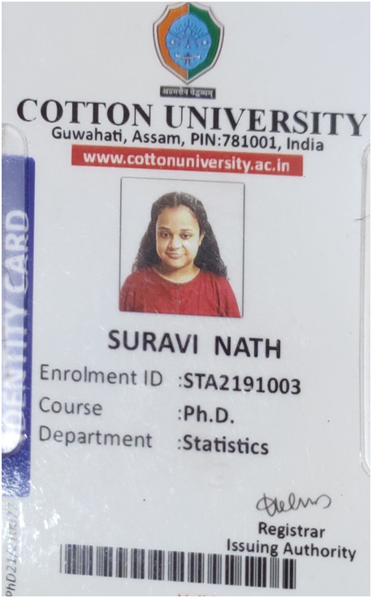 | 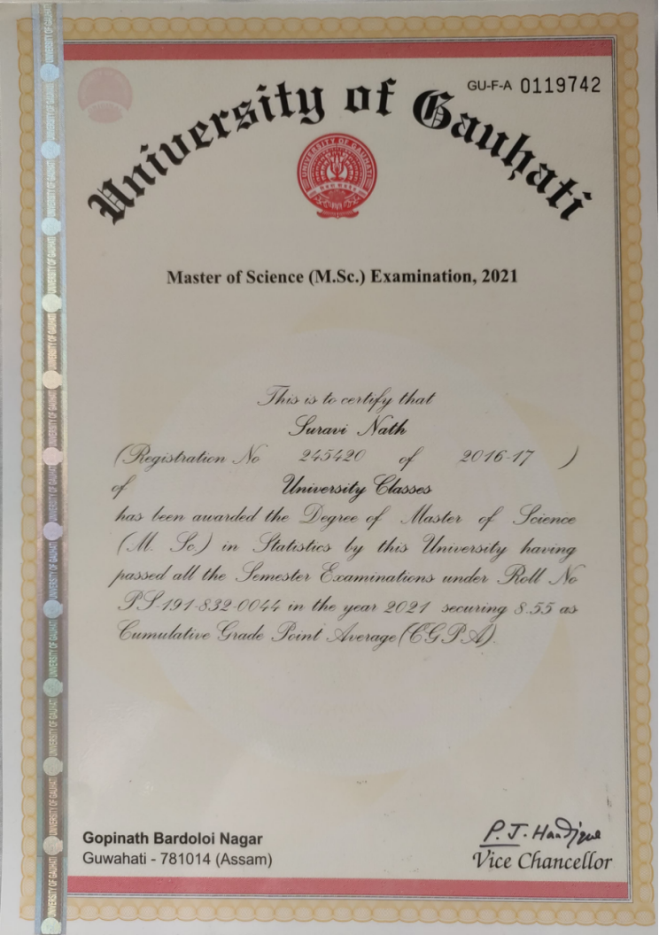

Sl No : 15 - Biju Roy
Name : Biju Roy
Batch :- 2017 - 2020
Qualification - B.Sc. in Statistics
Job Description / Business Description : Teacher in Govt. School
Place :
Date of Joining :

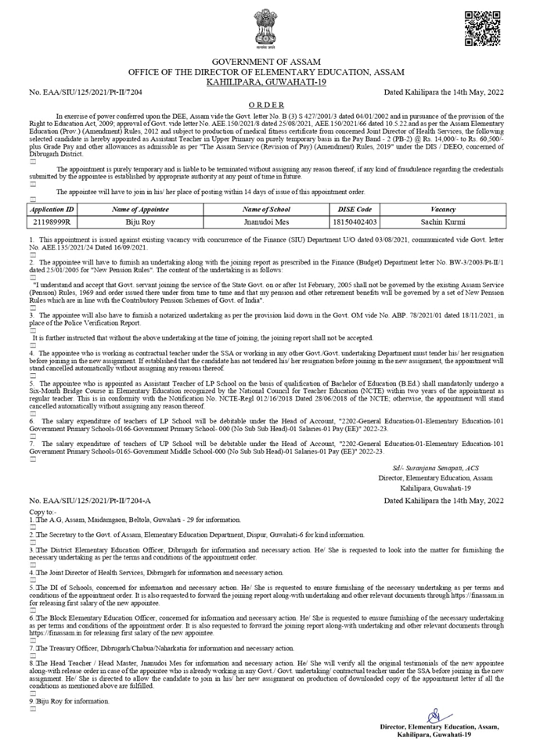

Sl No : 16 - Jupitora Pathak
Name : Jupitora Pathak
Batch :- 2017 - 2020
Qualification - B.Sc. in Statistics, B. Ed (Pursuing)
Job Description / Business Description :
Place :
Date of Joining :

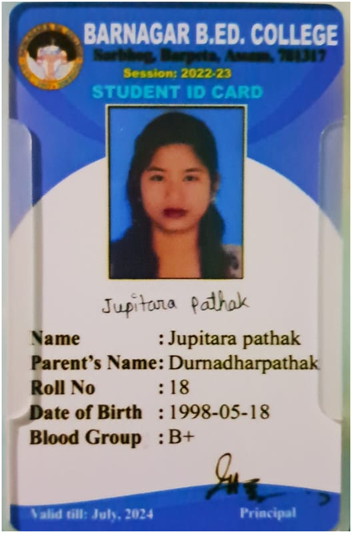
I Card

Sl No : 17 - Preetideep Gope
Name : Preetideep Gope
Batch :- 2017 - 2020
Qualification - M. Sc. In Statistics in Cotton University(Pursuing)
Job Description / Business Description :
Place :
Date of Joining :

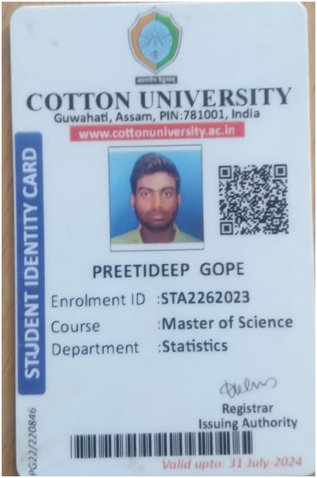

Sl No :18 - Manas Pratim Das
Name : Manas Pratim Das
Batch :- 2018 - 2021
Qualification - B. Sc. In Statistics
Job Description / Business Description : Chowkidar(MTS)
Place : Chapakhowa, Sadiya, Tinsukia
Date of Joining : 01/06/2023

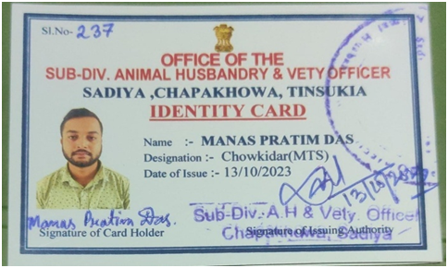

Sl No : 19 - Sanidul Islam
Name : Sanidul Islam
Batch :- 2018 - 2021
Qualification - M. Sc. In Statistics - (Pursuing)
Job Description / Business Description :
Place :
Date of Joining :

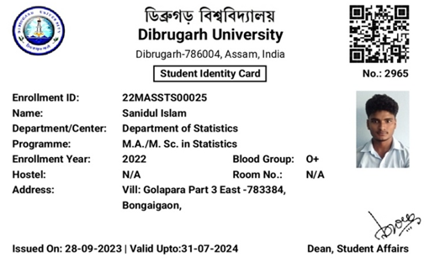

Sl No : 20 - Bigrai Boro
Name : Bigrai Boro
Batch :- 2018 - 2021
Qualification - M.C.A - (Pursuing)
Job Description / Business Description :
Place :
Date of Joining :

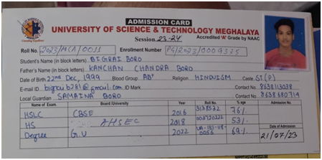

Sl No :21 - Bhaskar Jyoti Das
Name : Bhaskar Jyoti Das
Batch :- 2018 - 2021
Qualification - B. Sc. In Statistics
Job Description / Business Description : Block Level Fellow
Place : Goreswor Block, Tamulpur
Date of Joining : 31/10/2022

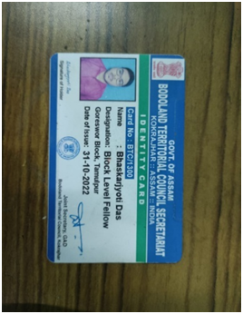

Sl No : 22- Sanjay Kherkatary
Name : Sanjay Kherkatary
Batch :- 2018 - 2021
Qualification - B. Sc. In Statistics
Job Description / Business Description : Constable (UB)/3335
Place : Guwahati
Date of Joining : 25/05/2023

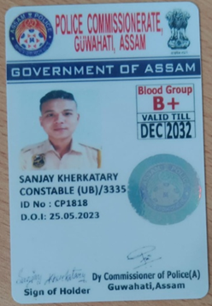

Sl No : 23 - Giyas Uddin
Name : Giyas Uddin
Batch :- 2018 - 2021
Qualification - M. Sc. In Statistics - Pursuing
Job Description / Business Description :
Place :
Date of Joining :

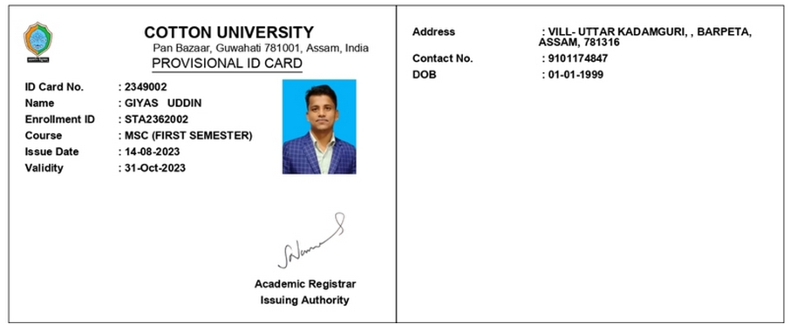

Sl No : 24 - Parbit Raj Srivastwa
Name : Parbit Raj Srivastwa
Batch :- 2018 - 2021
Qualification - BS In Data Science And Application
Job Description / Business Description :
Place :
Date of Joining :

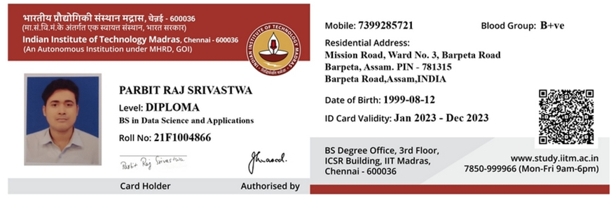

Sl No : 25 -Pralay Das
Name : Pralay Das
Batch :- 2019 - 2022
Qualification - BSc. in statistics
Job Description / Business Description :MTS
Place : Dudhnoi,Goalpara
Date of Joining : 23/06/23

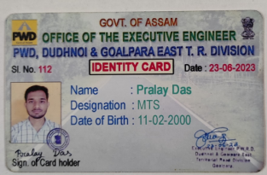 | 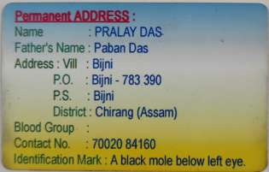

Sl No :26 -Nihar Pathak
Name : Nihar Pathak
Batch :- 2019 - 2022
Qualification - BSc. in Statistics
Job Description / Business Description :Pursing M.Sc in statistics
Place : Cotton University, Guwahati
Date of Joining :
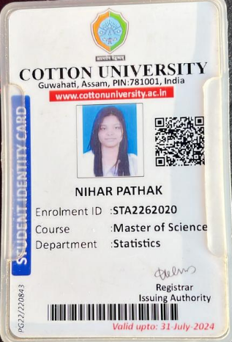 | 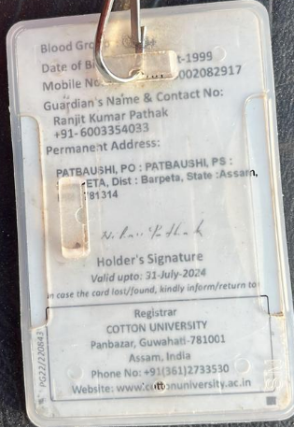

Sl No :27 -Arjun Barman
Name : Arjun Barman
Batch :- 2019 - 2022
Qualification - BSc. in Statistics
Job Description / Business Description :Office Peon(MTS)
Place :Office of the Executive Engineer,Bajali W.R Division::Pathsala
Date of Joining : 2023

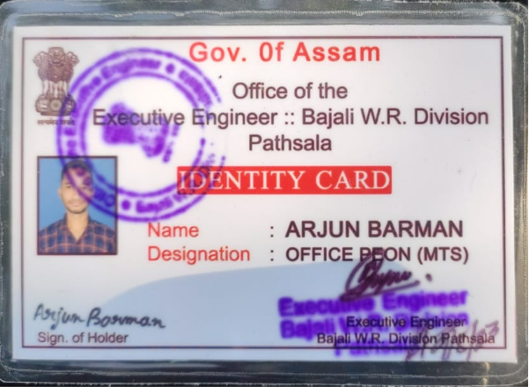 | 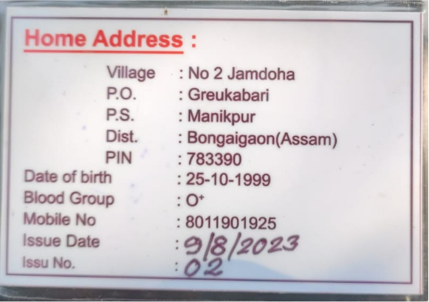

Sl No :28 -Pinki Brahma
Name : Pinki Brahma
Batch :- 2019 - 2022
Qualification - BSc. in Statistics
Job Description / Business Description pursuing MSc in Cotton University
Place : Guwahati
Date of Joining :

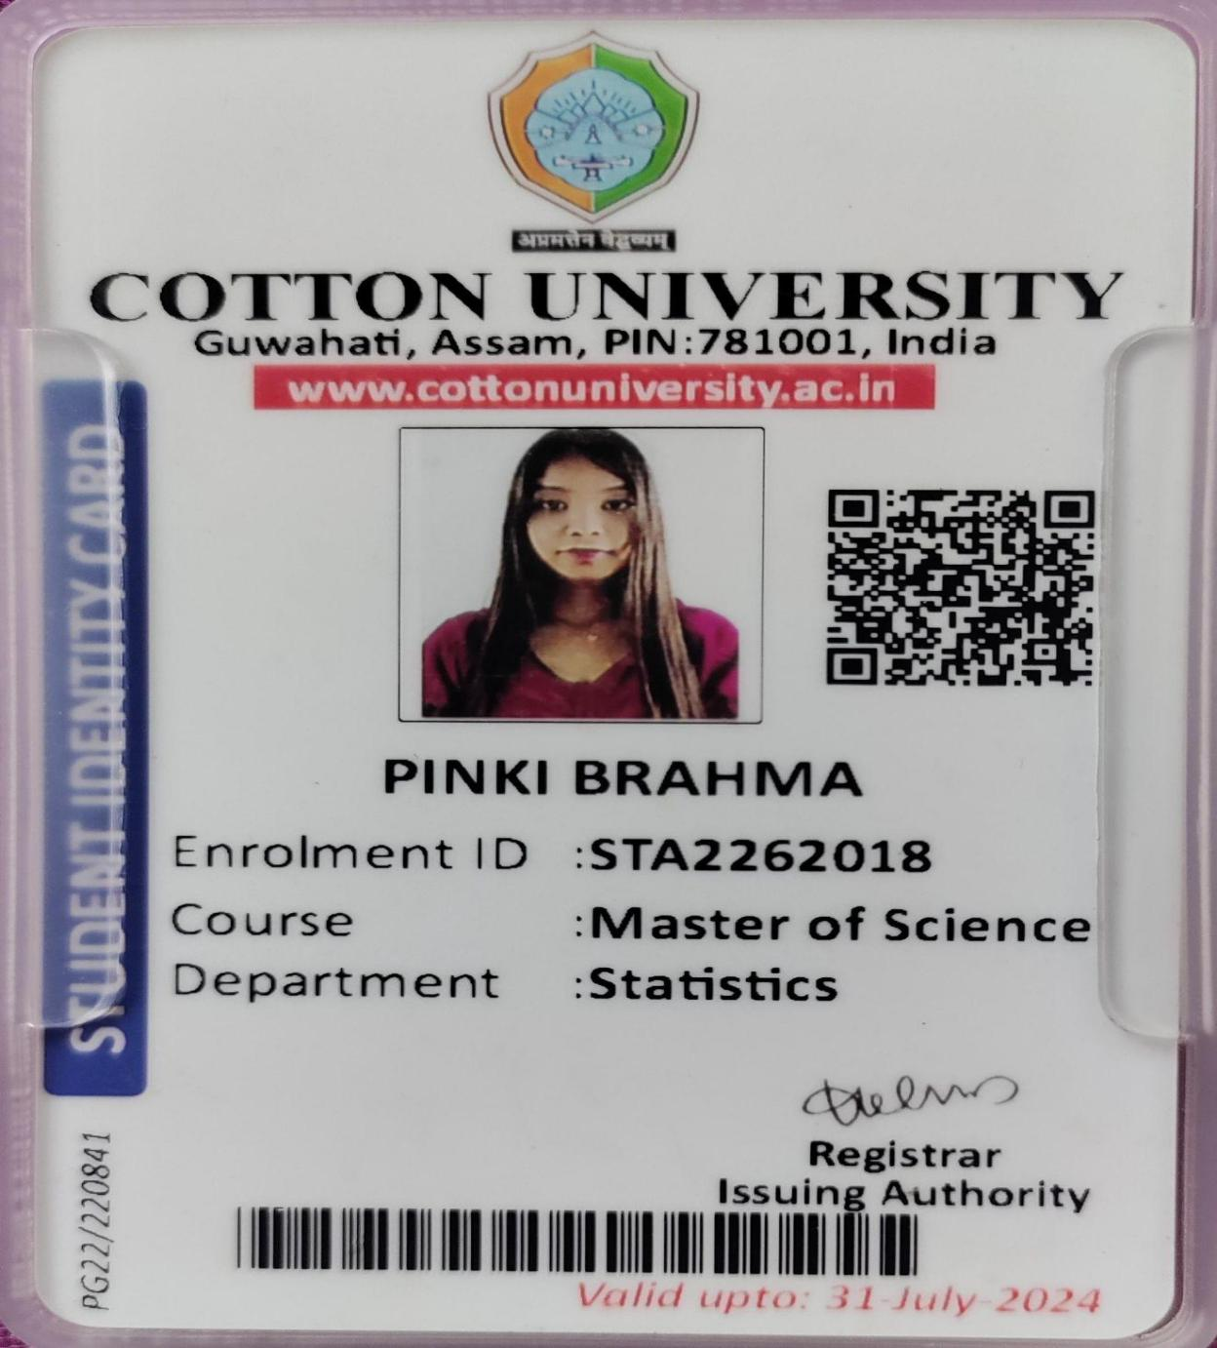

Sl No. 29 Partha Pratim Das
Batch: 2021-2024
Qualification - BSc. in Statistics
Job Description: MSc in Gauhati University
Place : Guwahati
Date of Joining: 2024
Sl No. 30 Ankita Das
Batch: 2021-2024
Qualification - BSc. in Statistics
Job Description: MSc in Bhattadev University
Place : Guwahati
Date of Joining: 2024

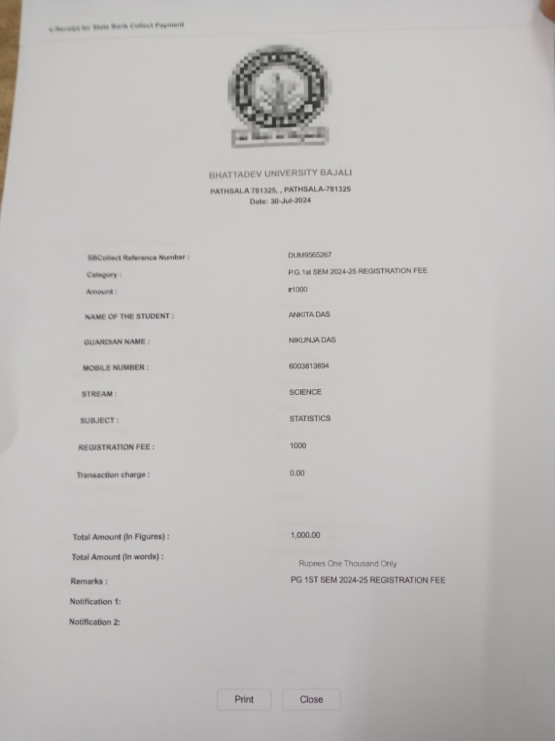
Sl No. 30 Rick Paul
Batch: 2021-2024
Qualification - BSc. in Statistics
Job Description: MSc in Bhattadev University
Place : Guwahati
Date of Joining: 2024
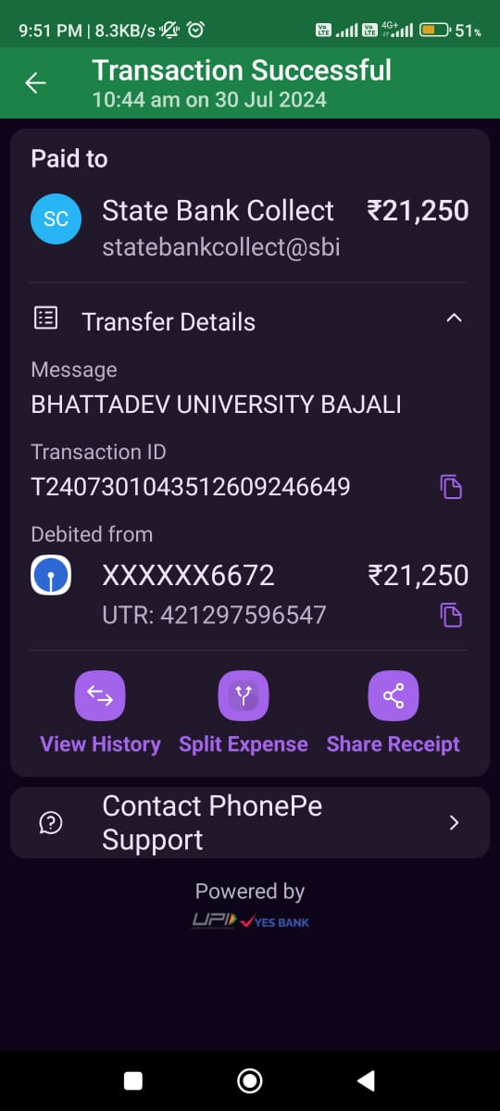

Sl No : 31 - Parbit Raj Srivastwa
Batch :- 2018 - 2021
Qualification - BS In Data Science And Application
Job Description / Business Description : Assistant Manager, Scale 1,General Insurance Corporation of India
Place : Mumbai
Date of Joining : 01/08/2024
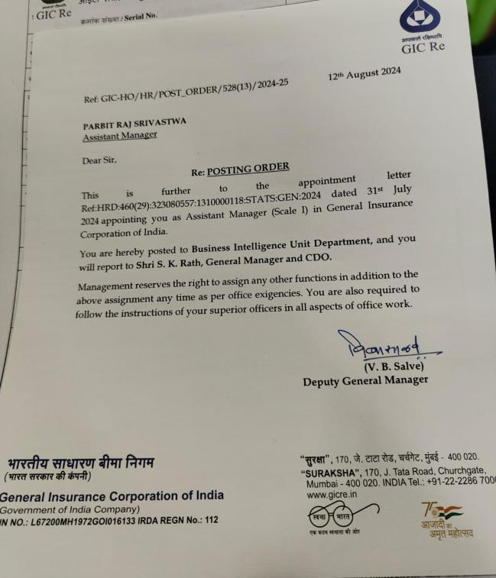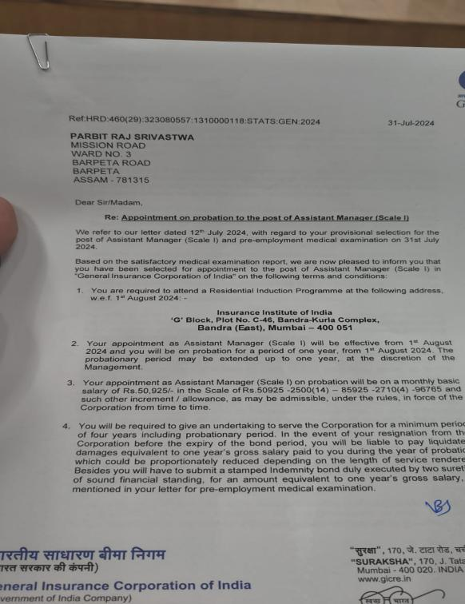

Sl No : 32 - Nafisa Lovna
Batch :- 2020 - 2023
Qualification - M.Sc in Statistics,Cotton University
Job Description / Business Description :
Place :
Date of Joining :

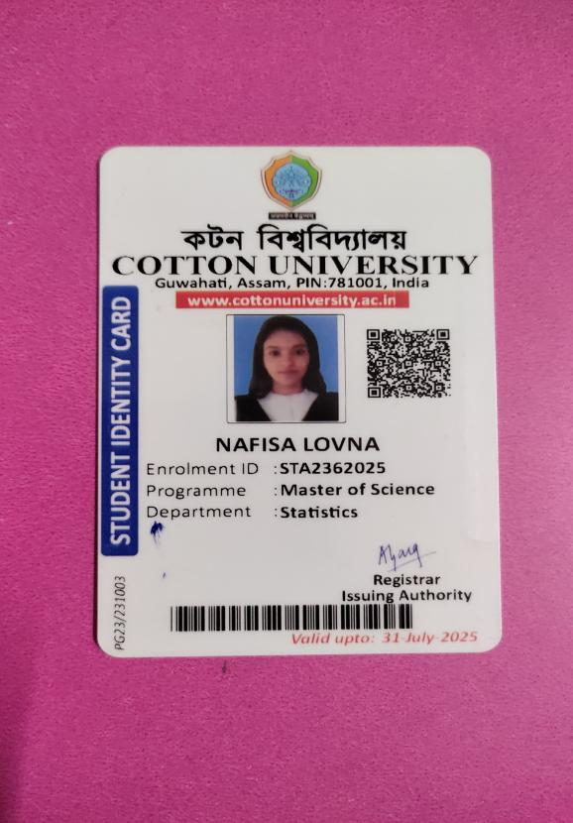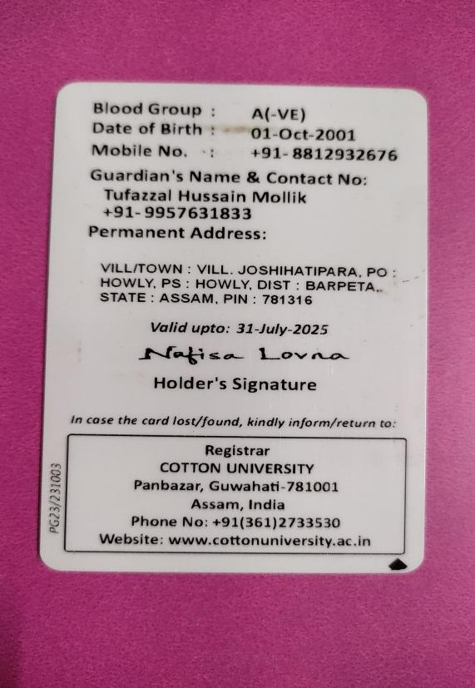

Sl No : 33-
Name :Biswajit Mandal
Batch :- 2020 - 2023
Qualification - M.Sc in Statistics,Gauhati University
Job Description / Business Description :
Place :
Date of Joining :

